# **A CRM APPLICATION FOR WHOLESALE RICE MILL**

# B**y**

## Jinakala Venu

#### venujinakala25@gmail.com

# Project Abstract

#### Introduction:

This project involves the development of a CRM application on the Salesforce platform tailored for wholesale rice mills. The application aims to enhance operational efficiency, improve data accuracy, and support strategic decisionmaking by integrating consumer management, inventory tracking, sales processing, and financial reporting into a single platform.

#### Objective:

To provide a centralized and user-friendly CRM system that streamlines core business processes, enhances customer relationship management, optimizes inventory levels, ensures accurate sales tracking, and facilitates comprehensive financial reporting.

Key Features:

1. Consumer Management:

- Detailed consumer profiles with fields like name, contact details, rice taken, and payment methods.

2. Rice Inventory Management:

- Track rice types, quantities, prices, and supplier information.

3. Sales Tracking:

- Record sales transactions including consumer details, rice types, quantities, and total amounts.

4. Payment Processing:

- Record payments with details such as amount paid, payment date, and mode of payment.

5. Reporting and Analytics:

- Generate detailed reports and dashboards on consumers, sales, payments, and inventory.

Conclusion:

The CRM application for wholesale rice mills harnesses Salesforce's capabilities to transform traditional operations. By integrating key business functions into a cohesive system, it enables rice mill businesses to operate efficiently, make informed decisions, and achieve sustainable growth.

# INDEX Page

Topics Page no

Introduction To Salesforce :

1. Creating Developer Account 06

2. Account Activation 07-08

Object :

3. Create Supplier Object 09

4. Create Rice Mill Object 10

5. Create Consumer Objects 11

6. Create Rice Details Objects 12

Tabs :

7. Creating A Custom Tab 13-15

8. Creating Remaining Tabs 16

The Lightning App :

9. Create A Lightning App 17-19

Fields :

10. Creating The Number Field In Rice Details Object 20-21

11. Creating Junction Object 22-24

12. Creating A Master-Detail Relationship 25

13. Creating The Roll-Up Summary 26-28

14. Creating Fields In Objects 29-30

15. Creating Fields In Rice Mill Objects 31

16. Creating Fields in Consumer Objects 32-33

17. Creating Cross Object Formula Field In Consumer Object 34-36

18. Creating The Validation Rule 37-38

Page Layouts :

19. Creating The Page Layout 39-41

Profiles :

20.Owner Profile 41-42

21. Employer Profile 43-44

22.Worker Profile 45-46

Role & Role Hierarchy :

23. Creating Owner Role 47-48

24.Creating Employer Roles 49-51

Users :

25. Create User 52-53

26.Creating Another Users 54

27. Create Another User 55

Permission Sets :

28.Creating OWD Setting 56-57

Report :

29.Create Report 58-60

30.Sharing Report To Owner 61-62

31. Create a Report Folder 63-65

Dashboards :

32. Create Dashboard Folder 66

33. Create Dashboard 67-71

APEX :

34.Create An Apex Class (ConsumerRecord) 72-73

35. Creating An Apex Trigger 74

## INTRODUCTION

In today's competitive landscape, wholesale rice mills must navigate complex operations and maintain high levels of efficiency to remain successful. Effective management of consumer relationships, inventory, sales, and financial transactions is crucial to achieving this goal. However, traditional methods of managing these processes are often cumbersome, error-prone, and time-consuming.

This project introduces a cutting-edge CRM (Customer Relationship Management) application built on the Salesforce platform, specifically designed to address the unique needs of wholesale rice mills. The application aims to provide a centralized, user-friendly platform that streamlines and automates core business processes, significantly enhancing operational efficiency and data accuracy.

The CRM application focuses on several key areas:

1. Consumer Management: It enables the rice mill to maintain comprehensive profiles for each consumer, capturing essential information such as contact details, rice purchases, payment methods, and more. This facilitates improved customer service and strengthens consumer relationships.

2. Rice Inventory Management: The application provides robust tools for tracking rice inventory, including details on rice types, quantities available, pricing, and supplier information. This ensures optimal stock levels and efficient inventory management, preventing both shortages and overstocking.

3. Sales Tracking: The system meticulously records all sales transactions, linking them to the appropriate consumers and inventory items. This allows for precise sales monitoring, trend analysis, and revenue tracking, offering valuable insights into business performance.

4. Payment Processing: Accurate tracking of payments is crucial for financial health. The application records all payment details, ensuring timely and accurate financial reconciliation and facilitating smooth financial operations.

5. Reporting and Analytics: Comprehensive reporting capabilities allow for the generation of detailed reports and dashboards, covering various aspects of the business. These insights support data-driven decision-making and strategic planning, helping the rice mill to identify opportunities for improvement and growth.

#### Task 1:

#### Creating Developer Account

1. Go to <https://developer.salesforce.com/signup>

2. On the sign up form, enter the following details :

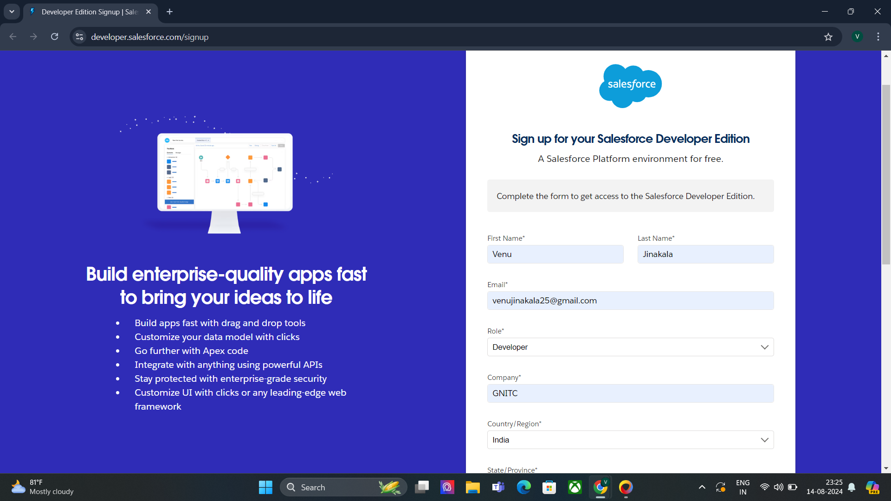

1. First name & Last name

2. Email

3. Role : Developer

4. Company : College Name

5. County : India

6. Postal Code : pin code

7. Username : should be a combination of your name and company

This need not be an actual email id, you can give anything in the format : [username@organization.com](mailto:username@organization.com)

Click on sign me up after filling these

#### Task 2:

#### Account Activation:

1. Go to the inbox of the email that you used while signing up. Click on the verify account to activate your account. The email may take 5-10mins.

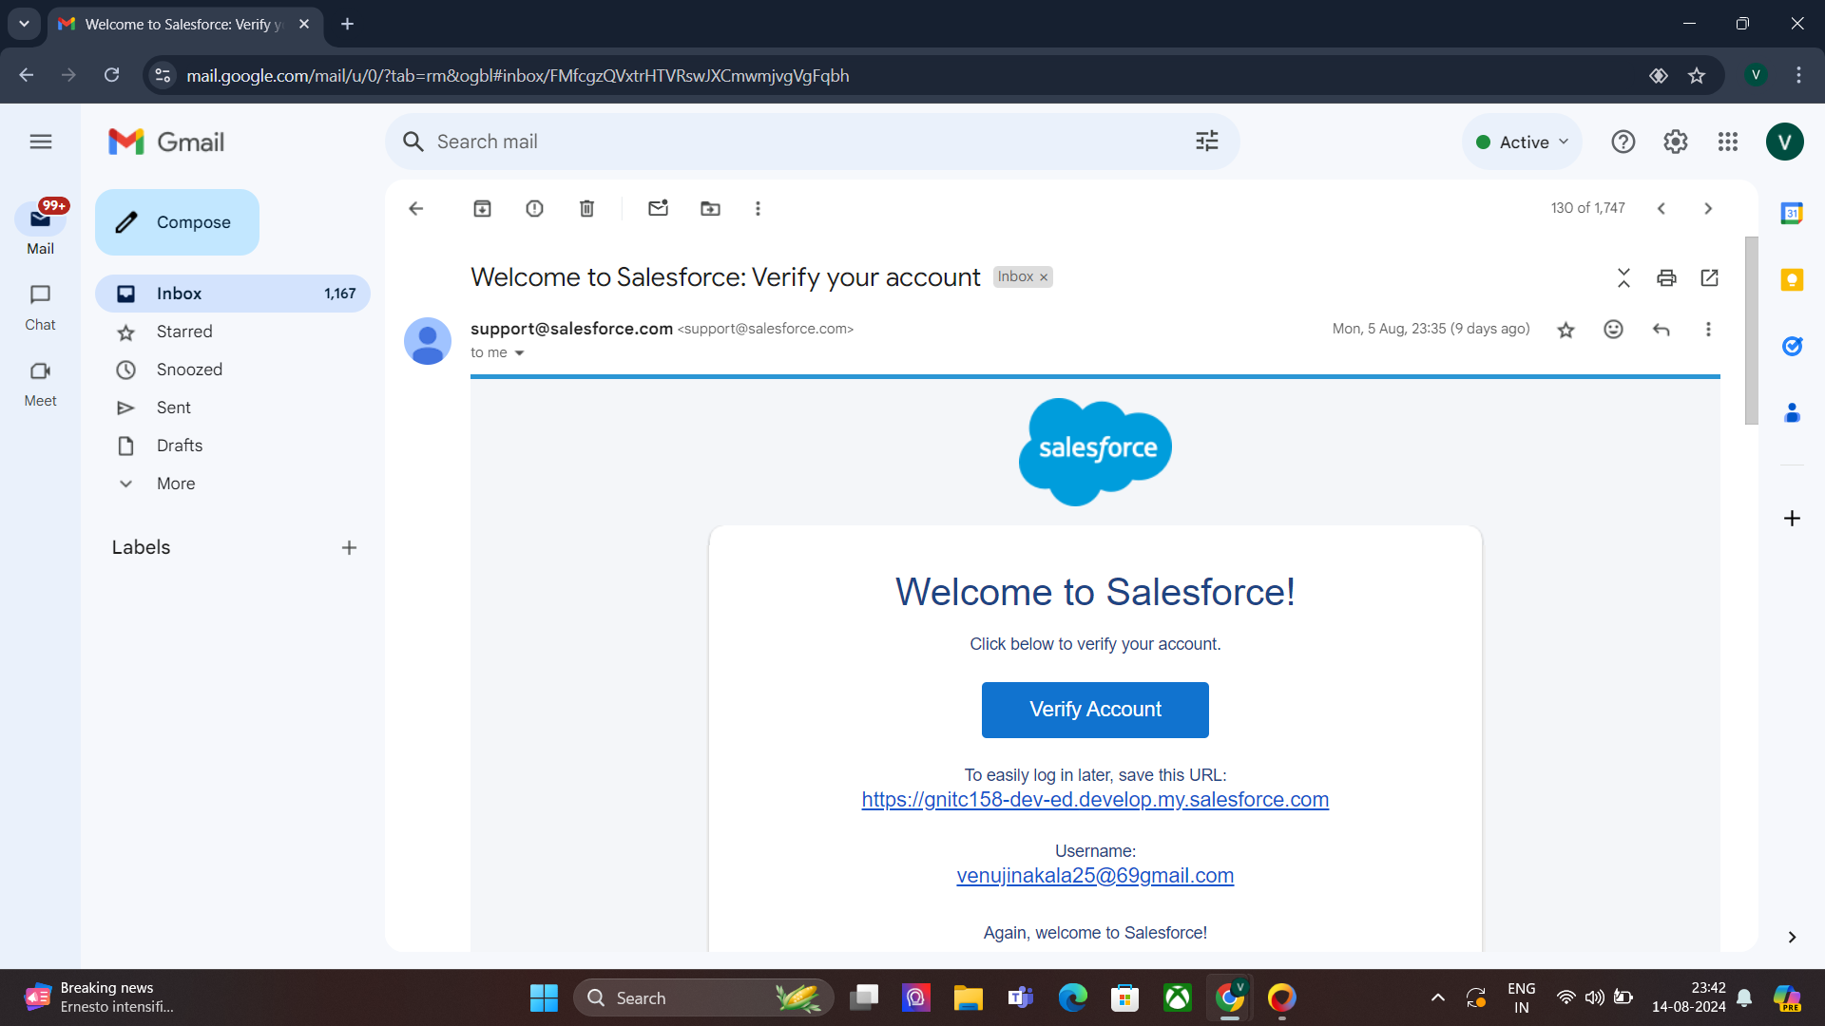

2. Click on Verify Account.

3. Give a password and answer a security question and click on change password.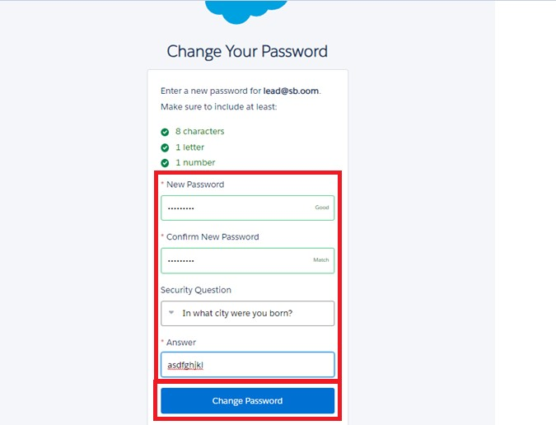

4. Then you will redirect to your salesforce setup page.

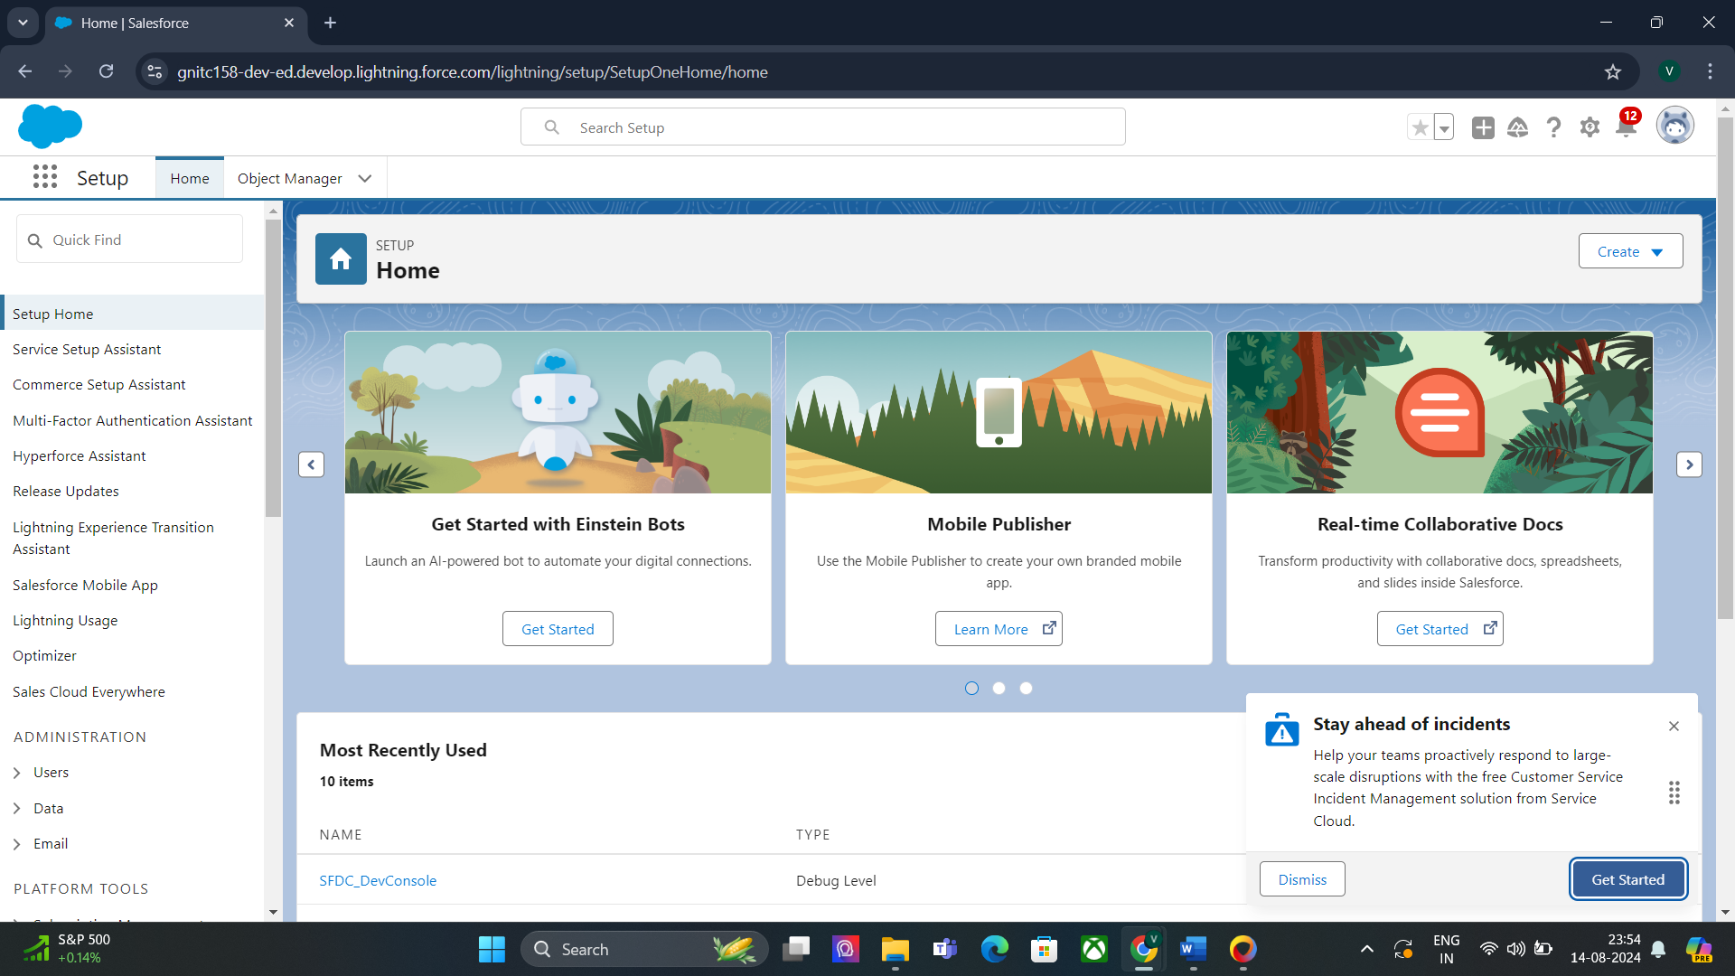

#### Task 3:

#### Create Supplier Object

To create an object:

1. From the setup page >> Click on Object Manager>> Click on Create>>Click on Custom Object.

1. Enter the label name>>supplier

2. Plural label name>>supplier

3. Enter Record Name Label and Format

● Record Name >> supplier Name

● Data Type>>Text

2. Click on Allow reports and Track Field History and allow search

3. Allow search >> Save.

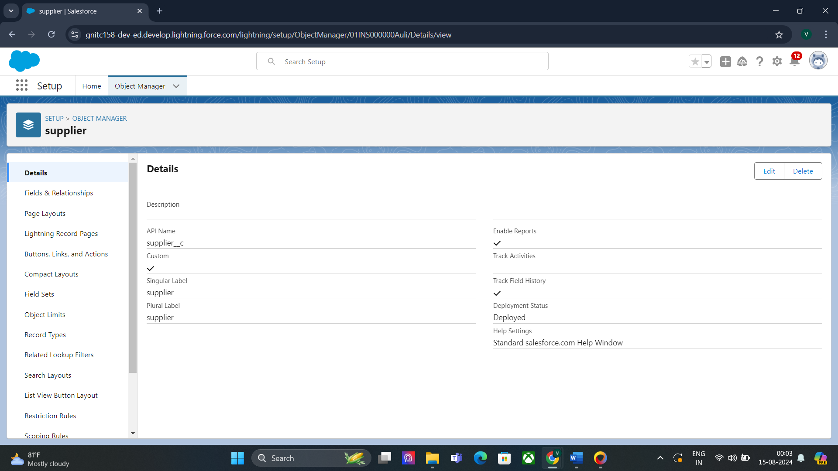

#### Task 4:

#### Create Rice mill Object

To create an object:

1. From the setup page >> Click on Object Manager>>Click on Create >> Click on Custom Object.

1. Enter the label name>>rice mill

2. Plural label name>> rice mills

3. Enter Record Name Label and Format

● Record Name >>

● Data Type >> Auto Number

● Display Format >> rice-{000}

● Starting number >> 1

2. Click on Allow reports and Track Field History, Allow Search and Save.

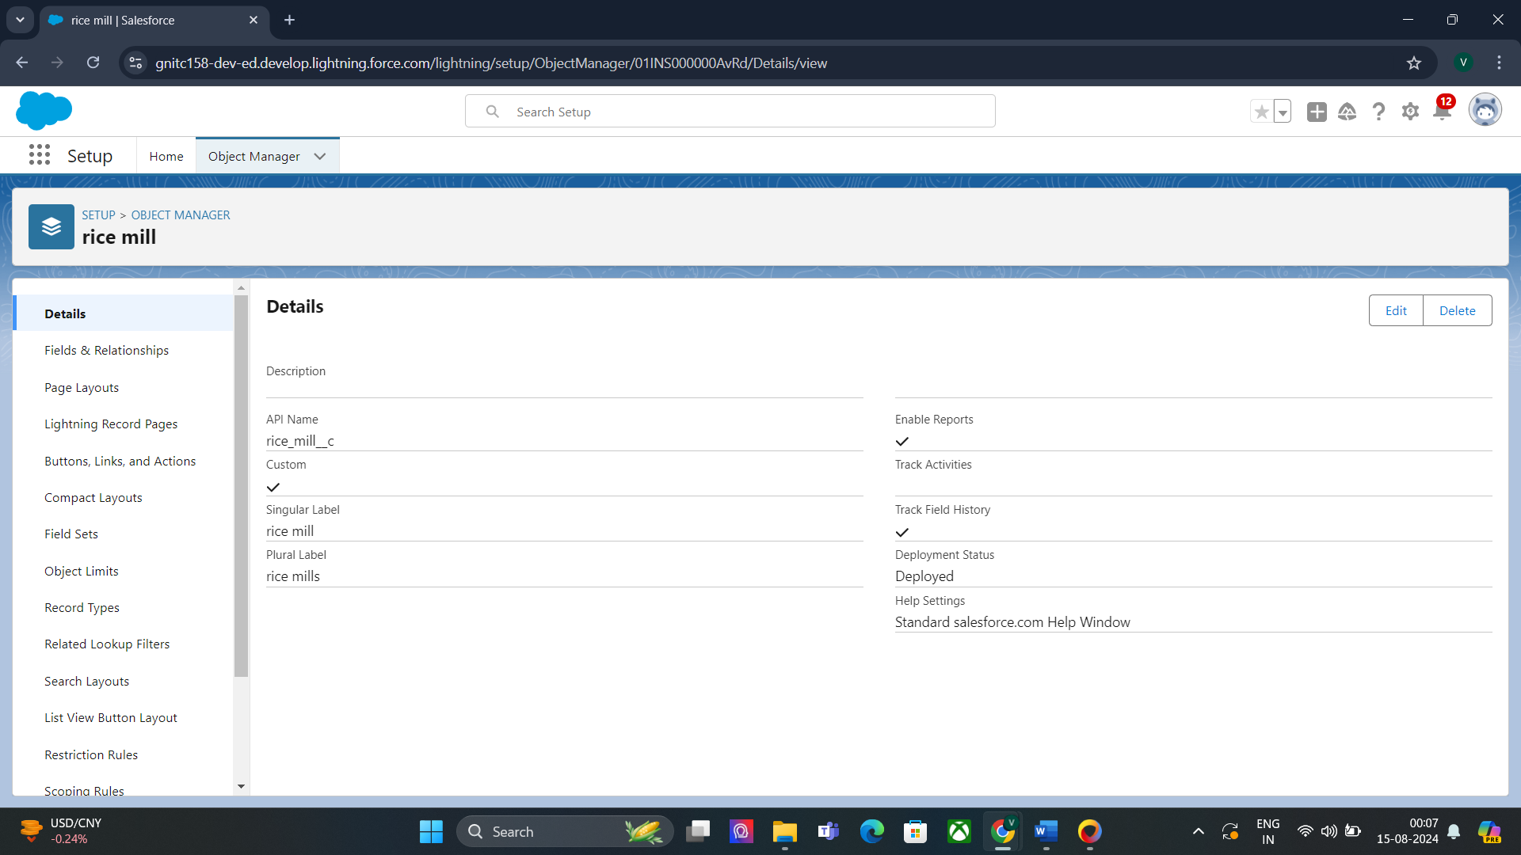

#### Task 5:

#### Create Consumer Objects

1. From the setup page >> Click on Object Manager>>Click on Create >> Click on Custom Object.

1. Enter the label name>>consumer

2. Plural label name>> consumers

3. Enter Record Name Label and Format

● Record Name >>

● Data Type >> Auto Number

● Display Format >> consumers-{000}

● Starting number >> 1

2. Click on Allow reports and Track Field History, Allow Search and Save.

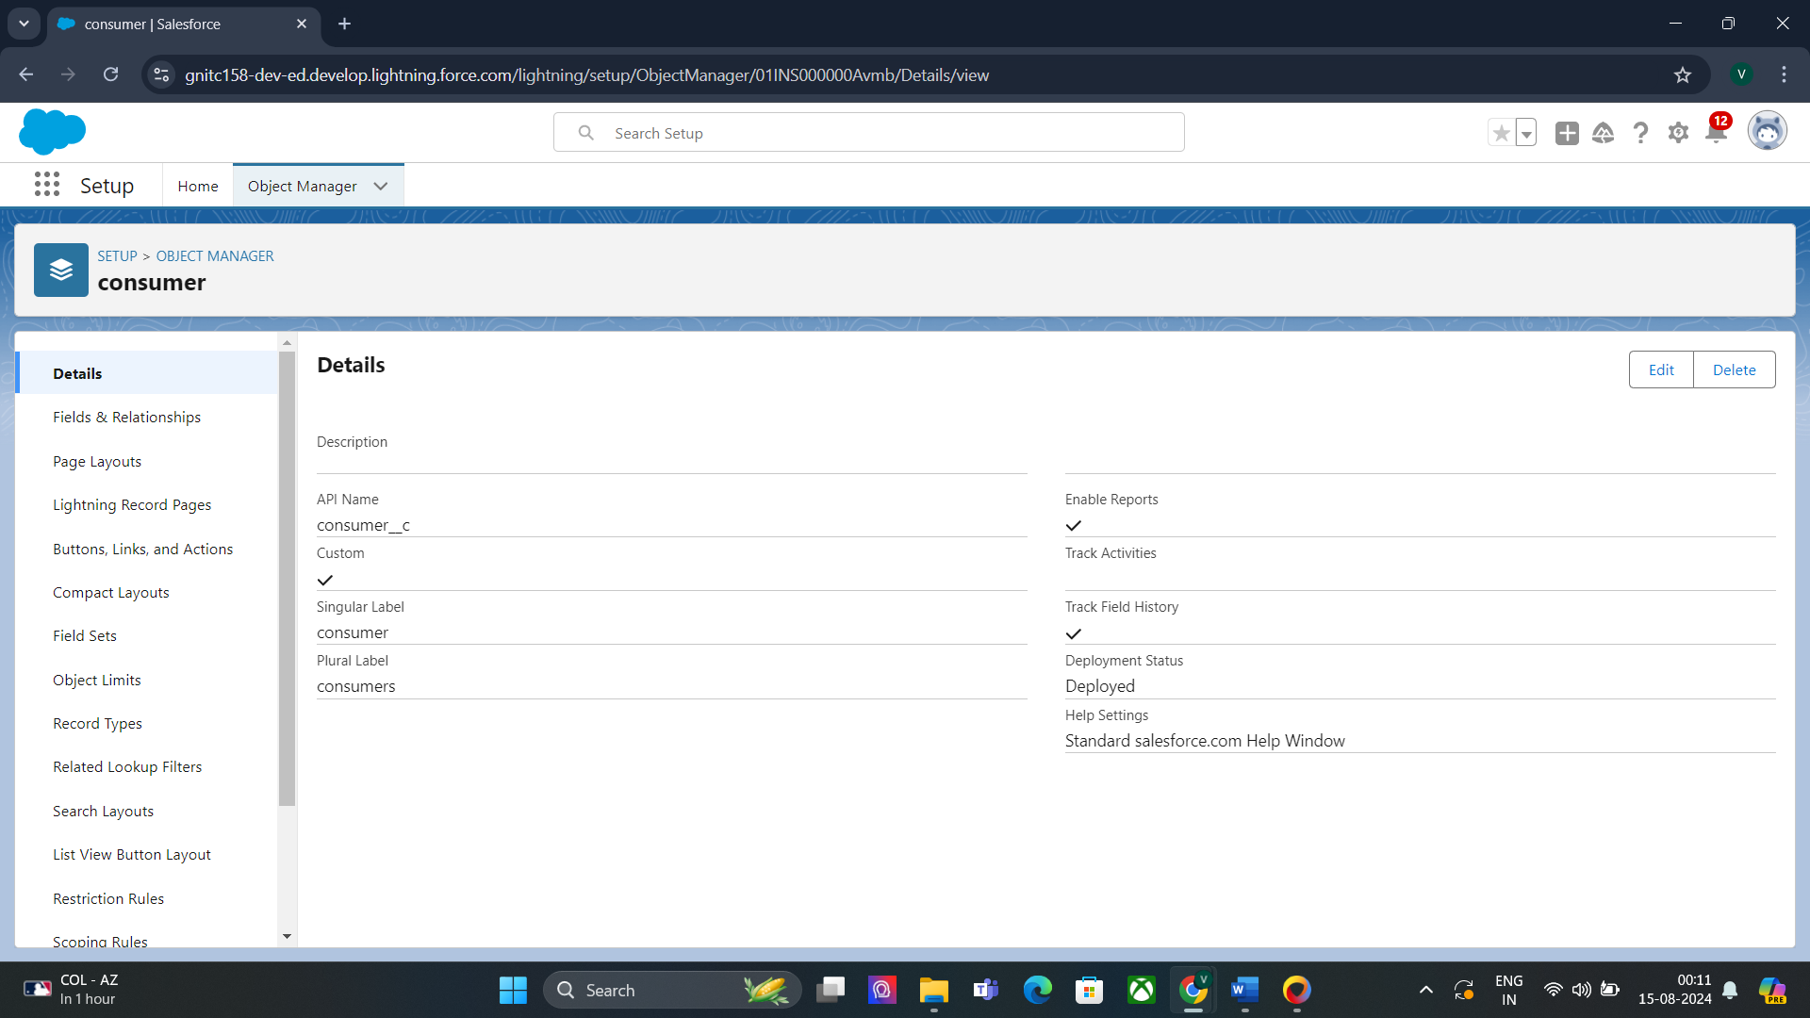

#### Task 6:

#### Create rice details Objects

#### 1. From the setup page >> Click on Object Manager>>Click on Create >> Click on Custom Object.

1. Enter the label name>>rice details

2. Plural label name>> rice details

3. Enter Record Name Label and Format

● Record Name >>

● Data Type >> Auto Number

● Display Format >> rice-{000}

● Starting number >> 1

2. Click on Allow reports and Track Field History, Allow Search and Save.

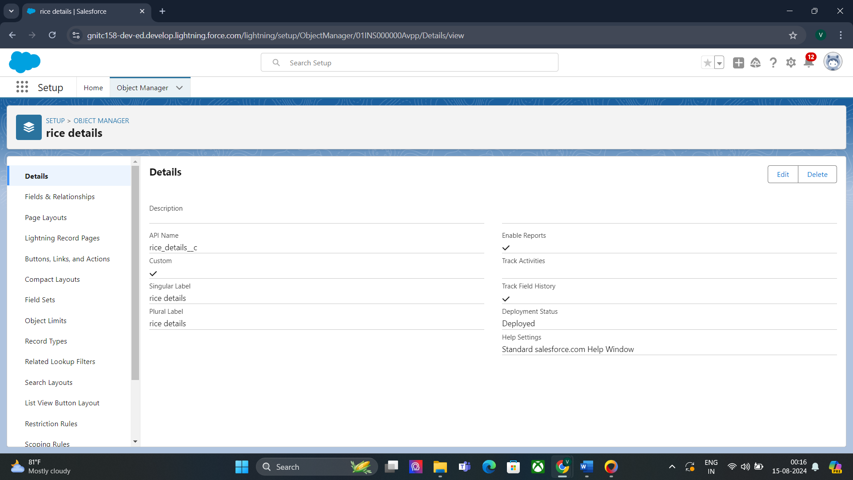

#### Task 7:

#### Creating a Custom Tab

To create a Tab:( supplier)

1. Go to setup page >> type Tabs in Quick Find bar >> click on tabs >> New (under custom object tab)

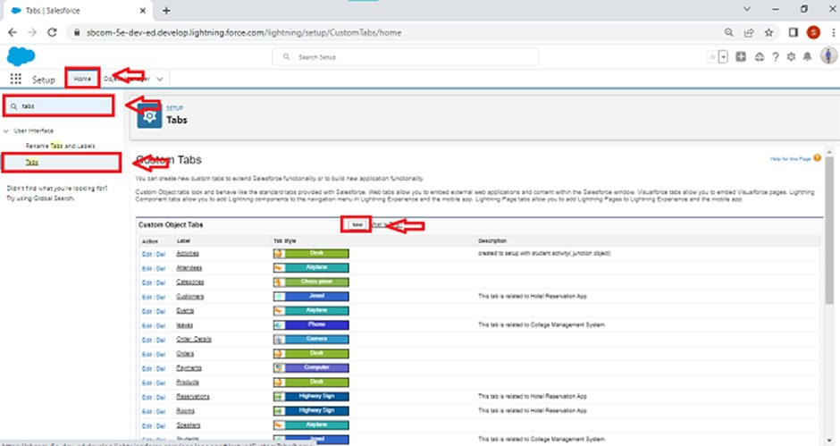

2. Select Object( supplier) >> Select the tab style >> Next (Add to profiles page) keep it as default >> Next (Add to Custom App) uncheck the include tab.

3. Make sure that the Append tab to users' existing personal customizations is checked.

4. Click save.

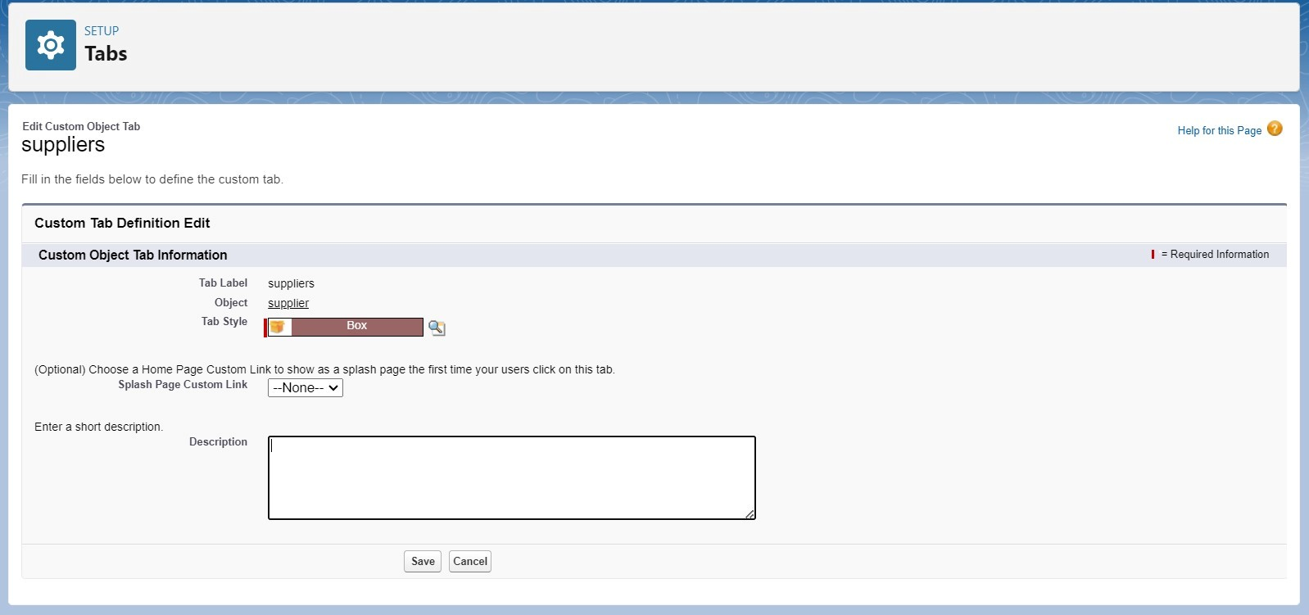

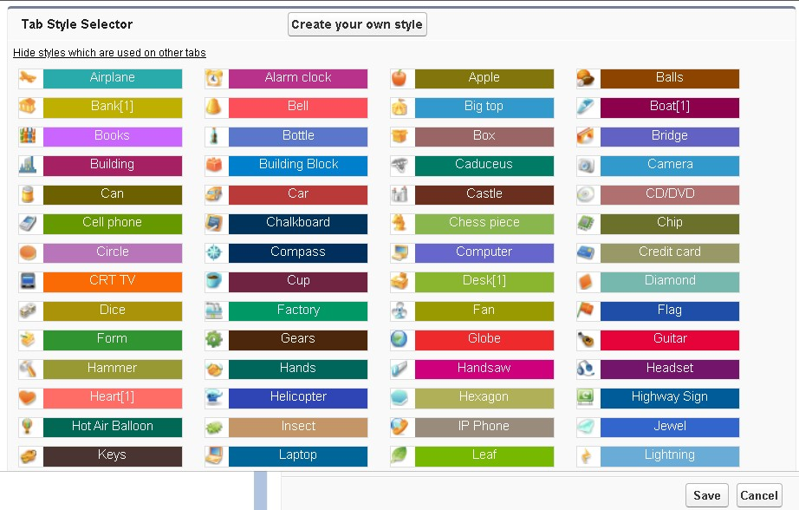

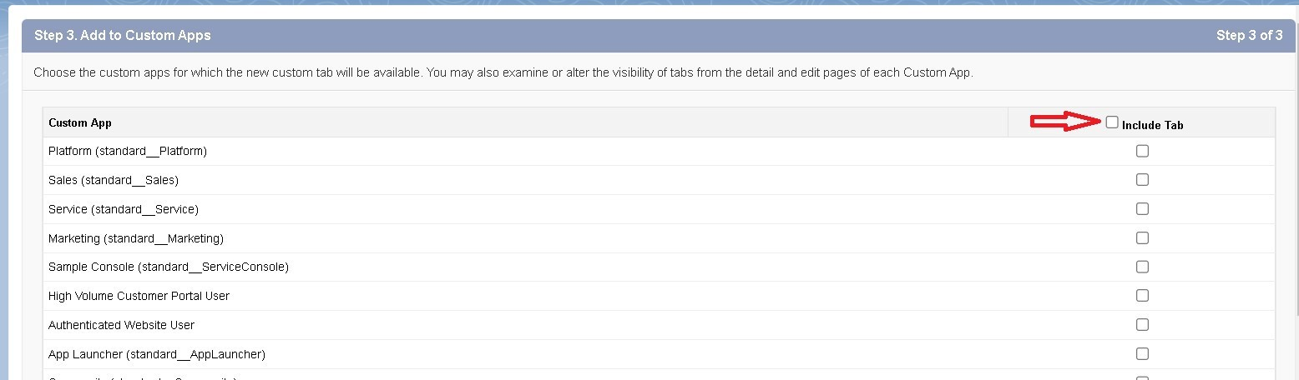

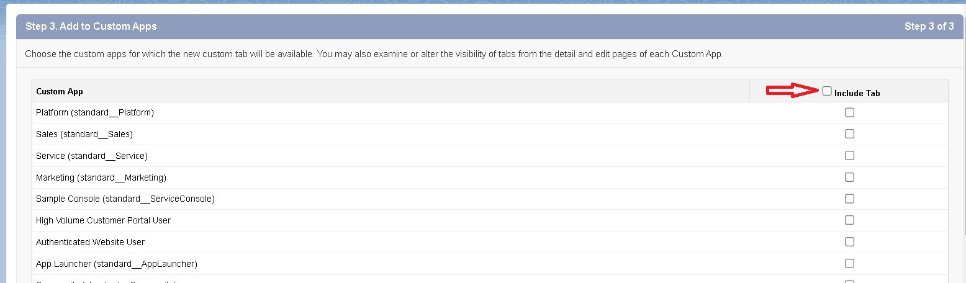

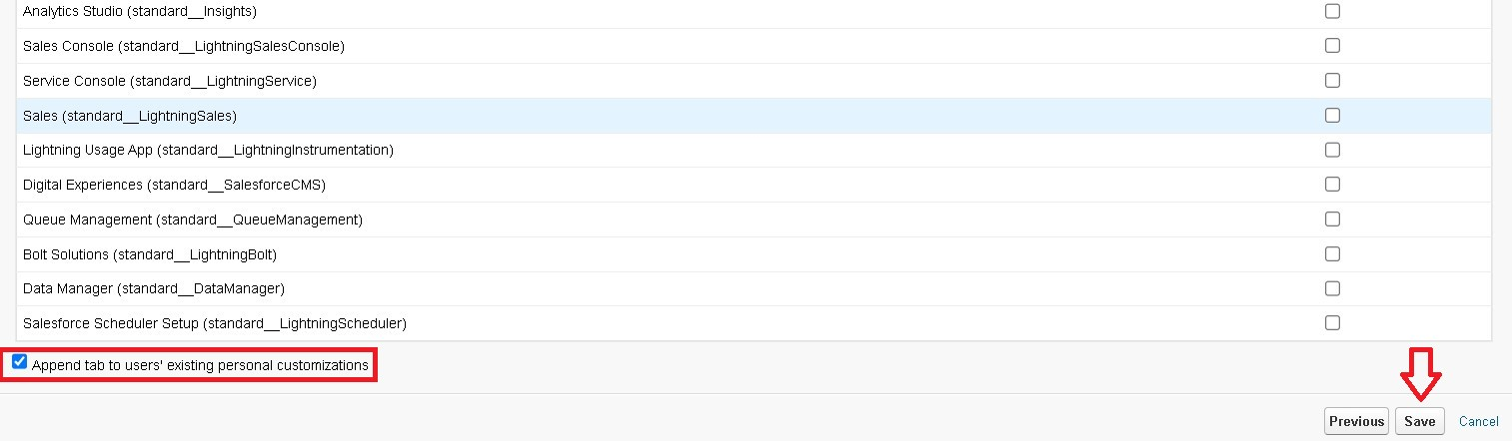

#### Task 8:

#### Creating Remaining Tabs

1. Now create the Tabs for the remaining Objects, they are “ rice mill, consumer , rice details”.

2. Follow the same steps as mentioned in Task 7.

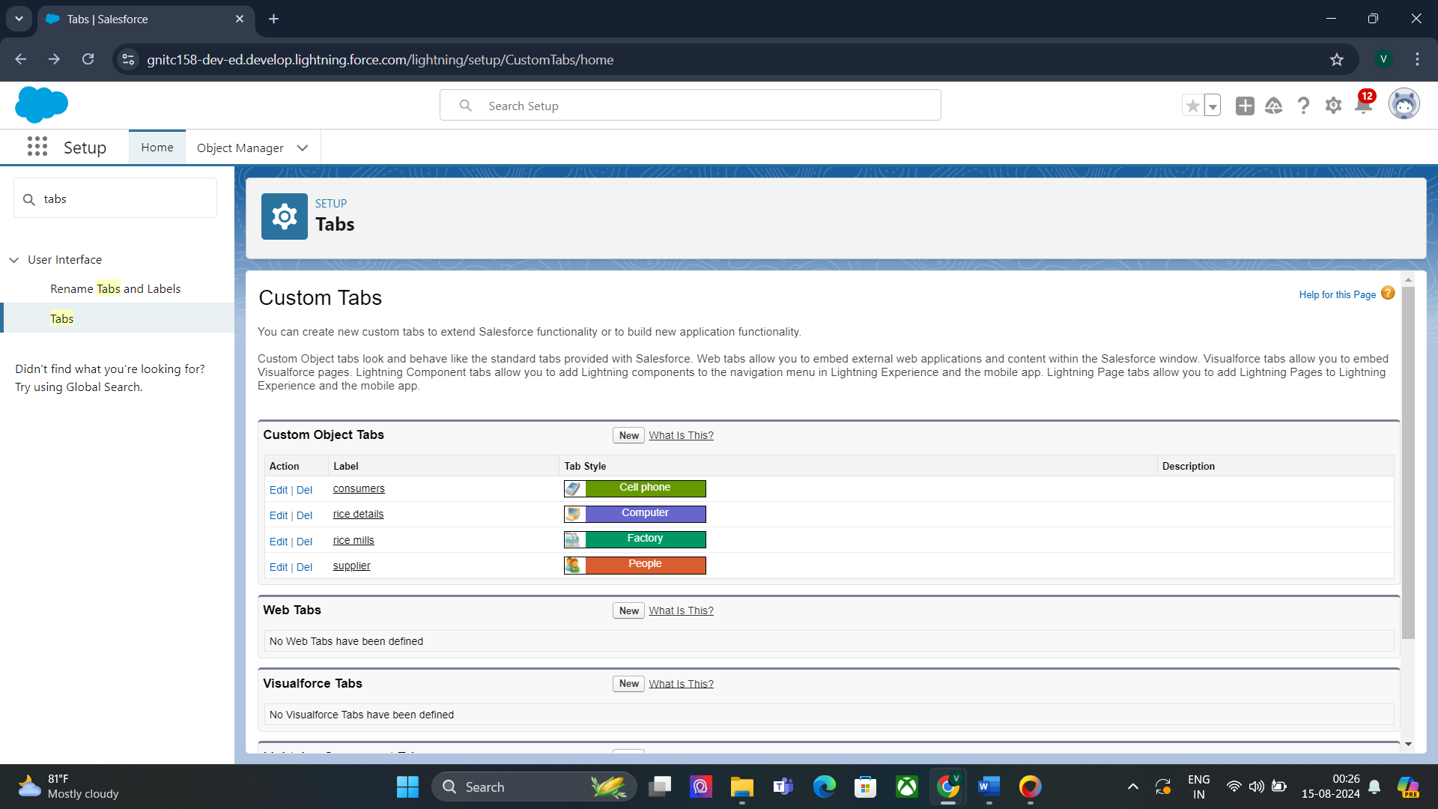

#### Task 9:

#### Create a Lightning App

To create a lightning app page:

1. Go to setup page >> search “app manager” in quick find >> select “app manager” >> click on New lightning App.

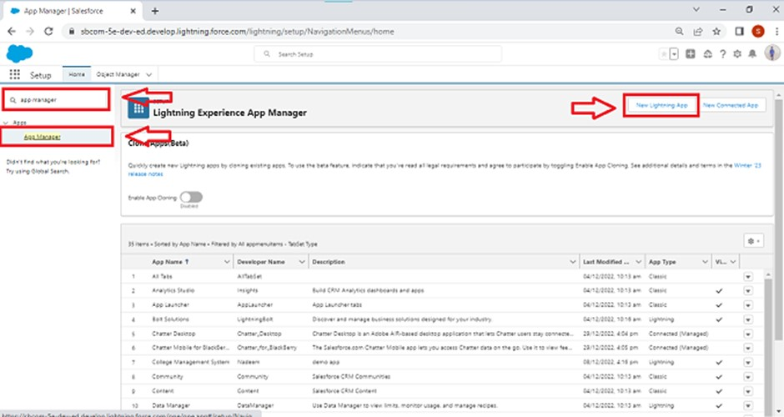

2. Fill the app name in app details as MY RICE >> Next >> (App option page) keep it as default >> Next >> (Utility Items) keep it as default >> Next.

3.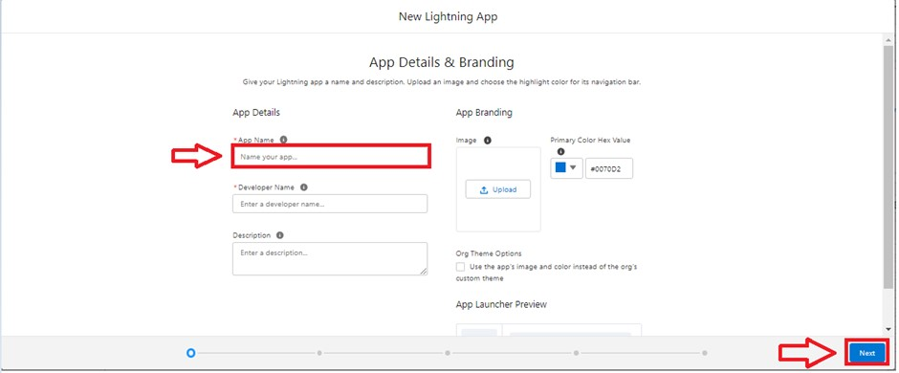

4. Upload a photo that is related to your app.

5. To add Navigation Item:  
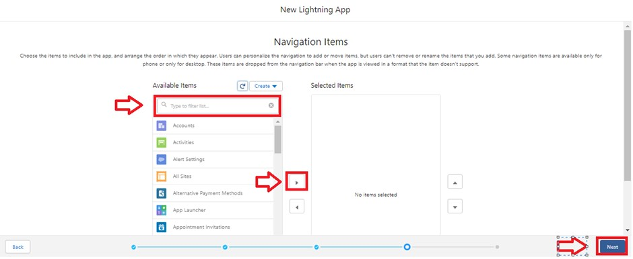

2. Select the items (supplier, rice mill, consumer , Rice details ) from the search bar and move it using the arrow button >> Next.

3. To Add User Profiles:

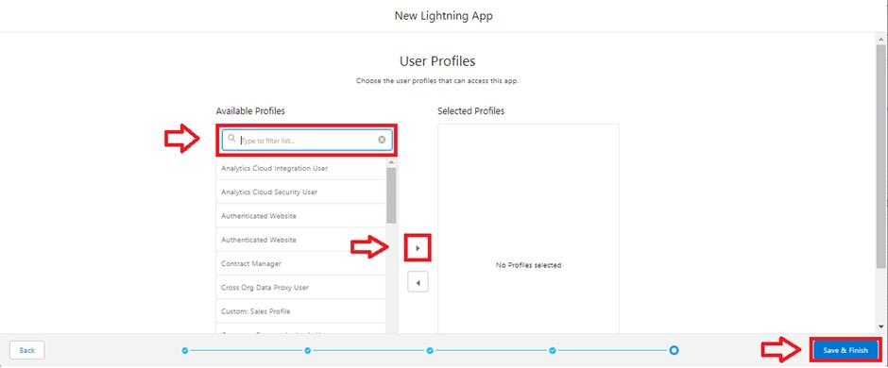

4. Search profiles (System administrator) in the search bar >> click on the arrow button >> save & finish.

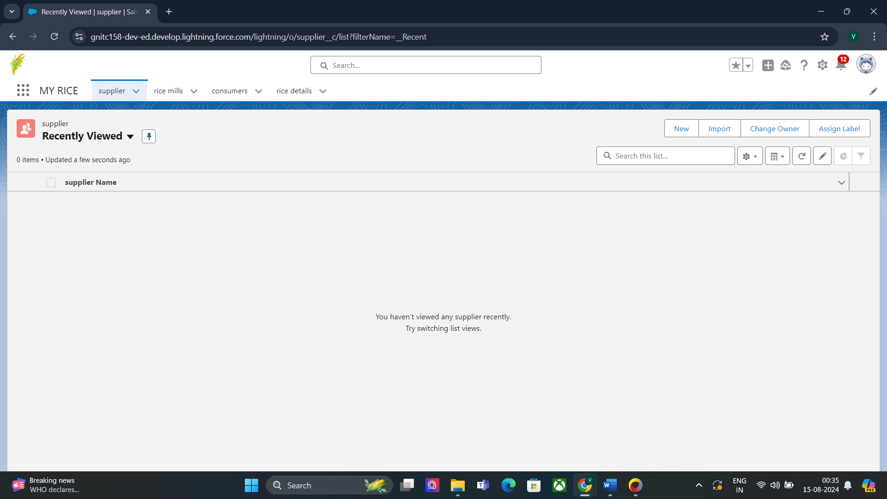

#### Task 10:

#### Creating the number field in rice details object

Creating the number field in rice details object

1. Go to the setup page >> click on object manager >> From drop down click edit for rice details object

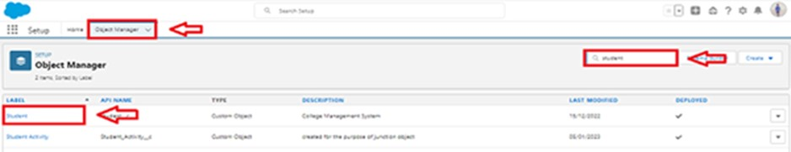

2. Click on fields & relationship >> click on New.

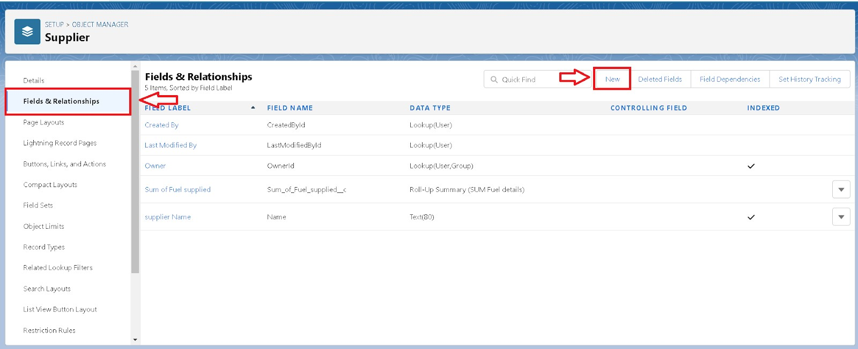

3. Select Data type as “Number” and click Next.

4. Given the Field Label as “ rice distributed ” and length as “ 5 ”.

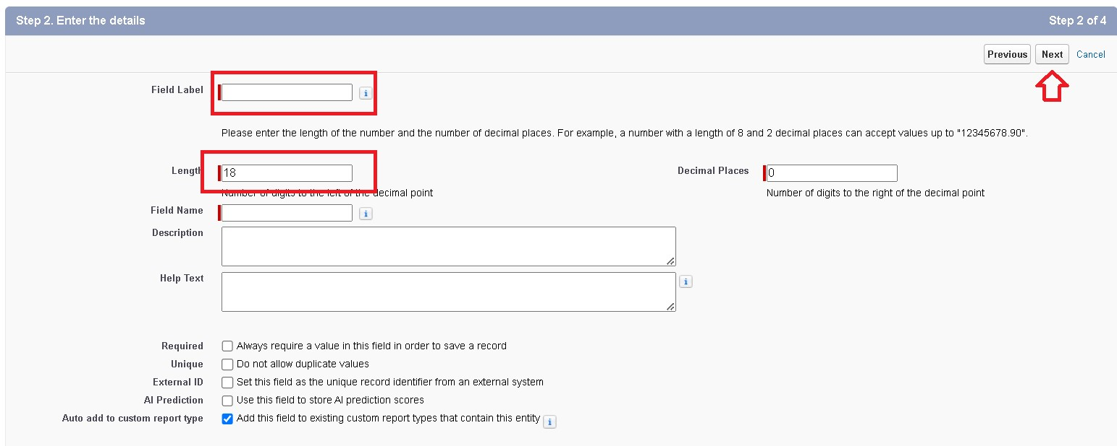

5. Field Name will be auto populated, and click on Next- Next >> Save.

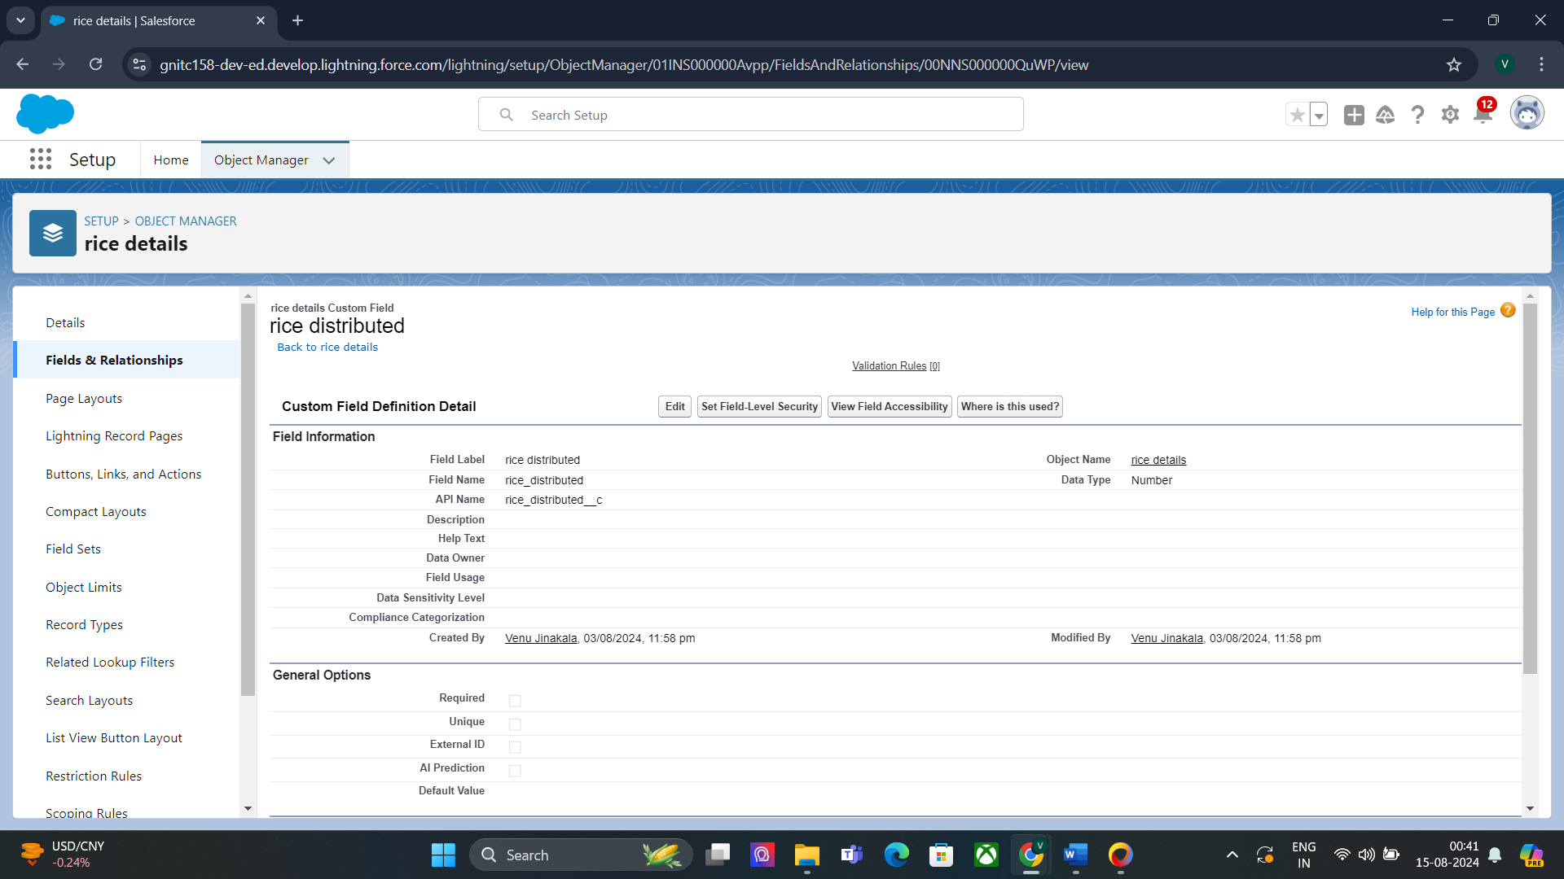

#### Task 11:

#### Creating Junction Object

1.Go to the setup page >> click on object manager >> From drop down click edit for rice details object



2. Click on fields & relationship - click on New.



3. Select “Master-Detail relationship” as data type and click Next.

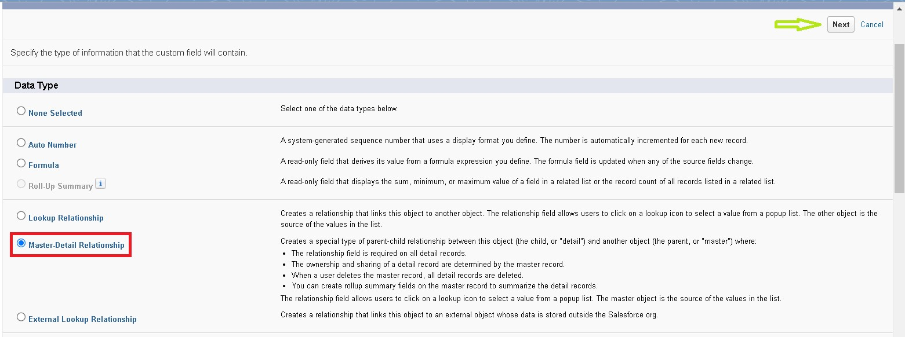

4. Select the related object “ supplier ” and click next.

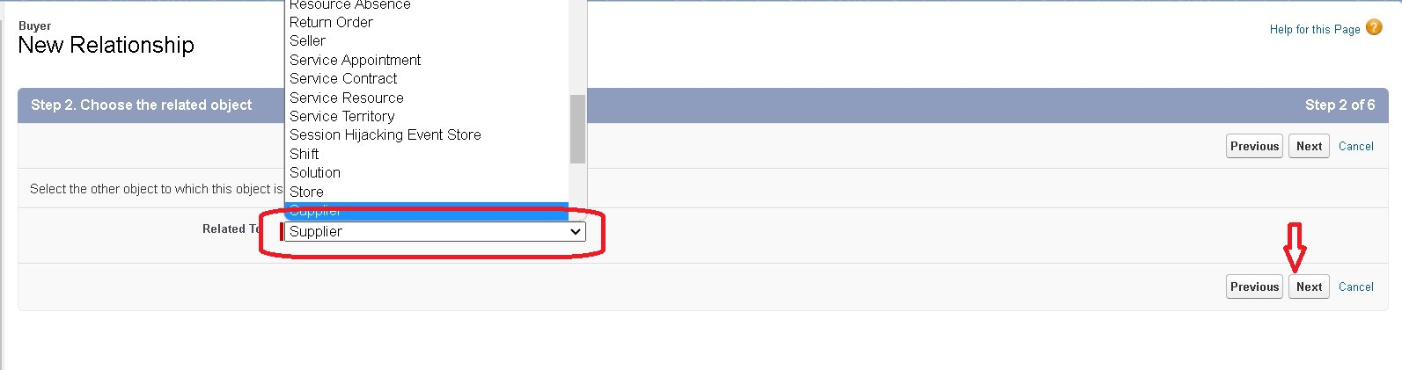

5. Give Field Label as “supplier Name” and click Next.

6. Next >> Next >> Save & New.

7. Follow the same steps from 1 to 3.

8. Select the related object “ rice mill ” and click Next.

9. Give Field Label as “rice mill 1(one)” and click Next.

10. Next >> Next >> Save.

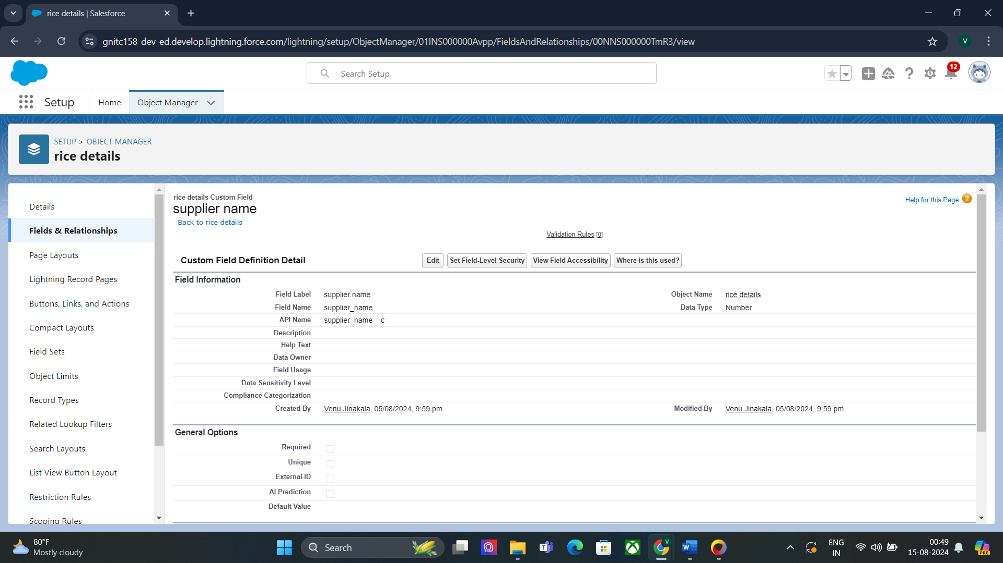

#### Task 12:

#### Creating a Master-Detail Relationship

Creating Master-Detail Relationship between consumer & rice mill Object To Create a Master-Detail relationship

1. Go to the setup page >> click on object manager >> From drop down click edit for consumer object.

2. Click on fields & relationship >> click on New.

3. Select “Master-Detail relationship” as data type and click Next.

4. Select the related object “ rice mill”.

5. Give Field Label as “rice mill name” and click Next.

6. Next >> Next >> Save.

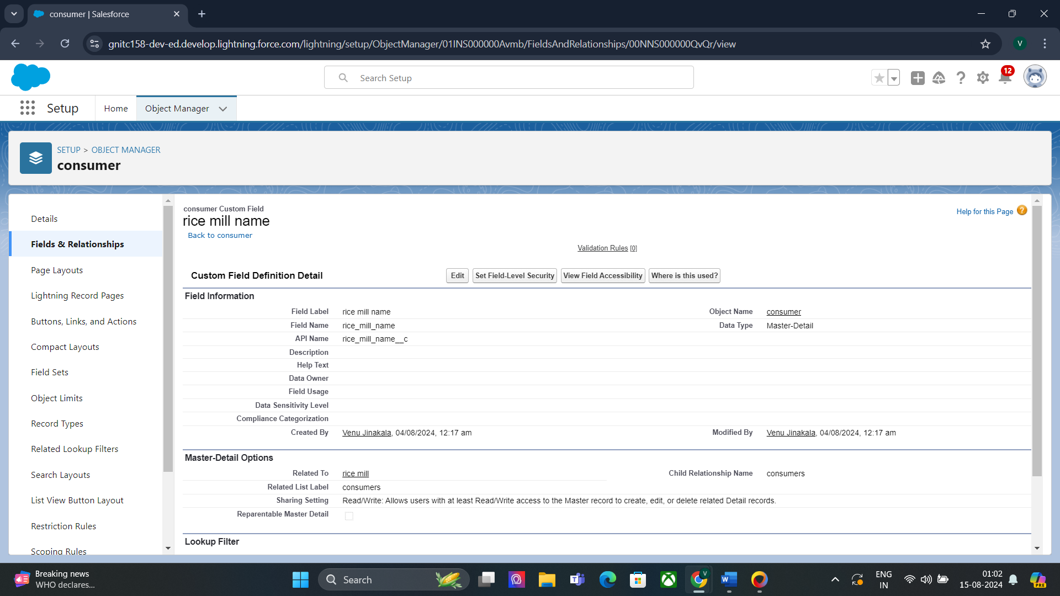

#### Task 13:

#### Creating the Roll-up Summary

1. Go to setup >> click on Object Manager >> type object name(supplier) in search bar >> click

on the object.



2. Now click on “Fields & Relationships” >> New

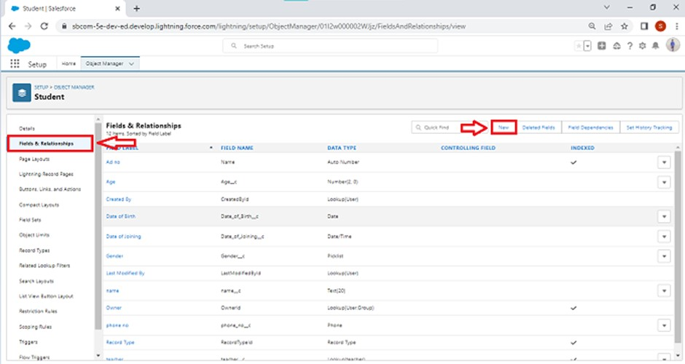

3. Select the data type as “Rollup summary ”,and click Next.

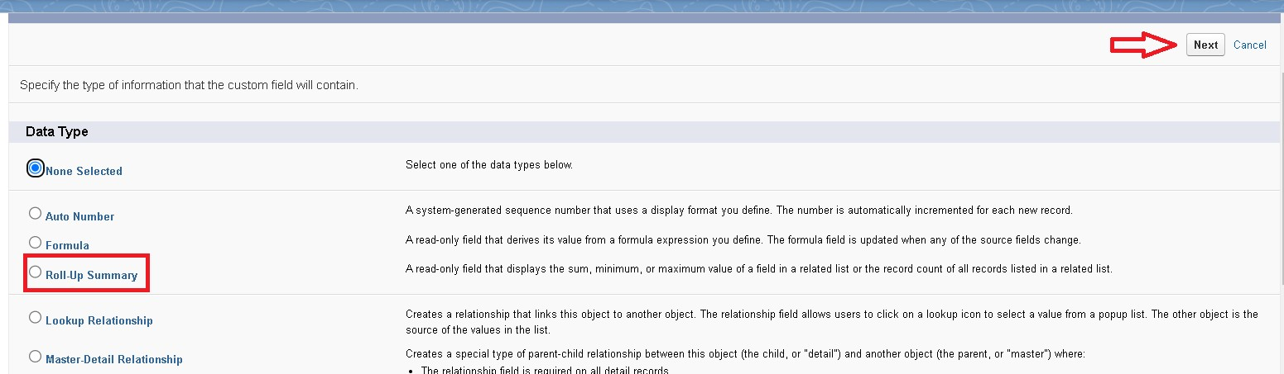

4. Give the Field label as “ sum of rice distributed ”,Field Name will be Auto generated, and click Next.

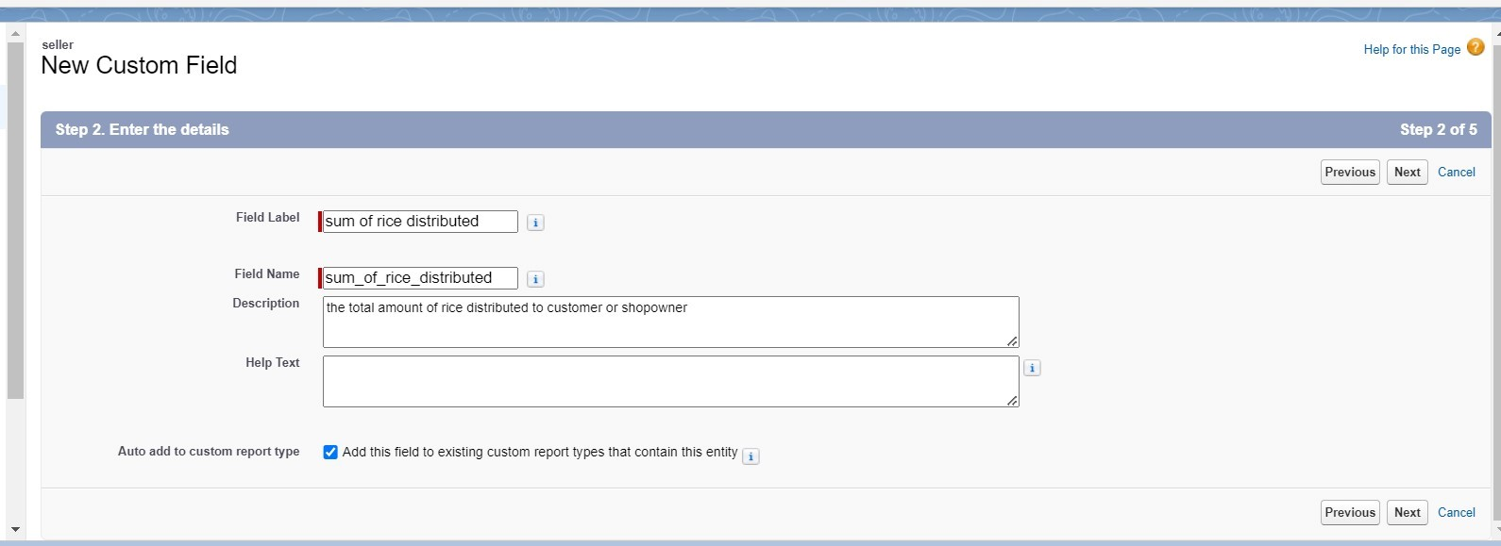

5. Select the summarized object as “ rice details ”.

6. Select the Rollup type as “sum”.

7. Select the field to aggregate as “ rice distributed ”, and click Next >>Next >>Save.

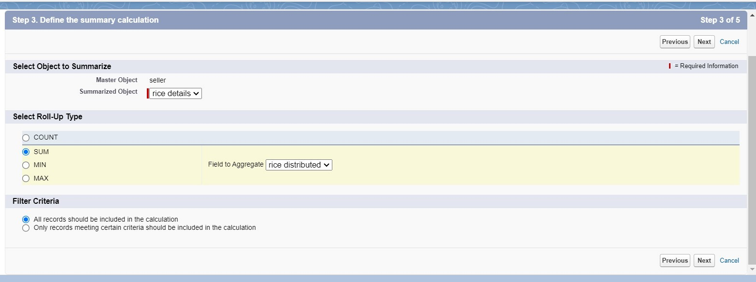

9. Follow the same steps for the rice mill Object from 1 to 3

10. Give the Field label as “ rice distributed to shops ”,Field Name will be Auto generated, and click Next.

11. Select the summarized object as “ rice details ”.

12. Select the Rollup type as “sum”.

13. Select the field to aggregate as “ rice distributed ”, and click Next >> Next >> Save.

14. Note : create the field as “ rice taken by shops in kgs” using number datatype in consumer object

15. Follow the same steps for the rice mill Object from 1 to 3

16. Give the Field label as “ rice taken ”,Field Name will be Auto generated, and click Next.

17. Select the summarized object as “ consumer”.

18. Select the Rollup type as “sum”.

19. Select the field to aggregate as “ rice taken in shops ”, and click Next >> Next >> Save.

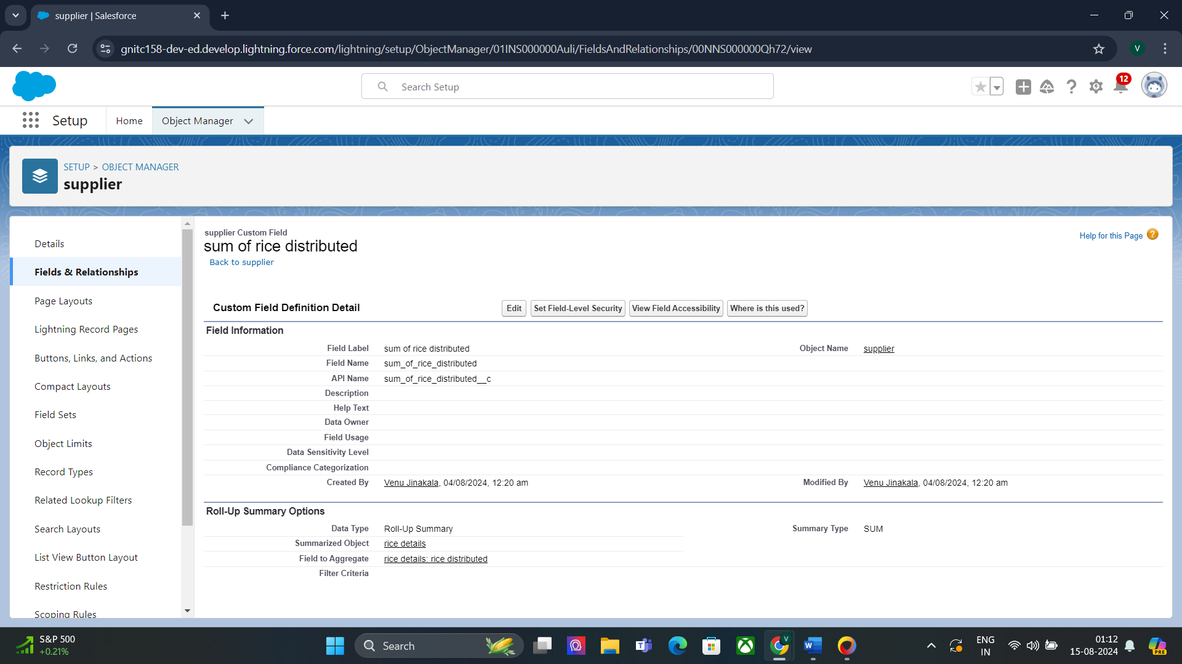

#### Task 14:

#### Creating Fields in Objects

Creating the number field in rice details object

1. Go to the setup page >> click on object manager >> From drop down click edit for rice details object.

2. Click on fields & relationship >> click on New.



3. Select Data type as “number" and click Next.

4. Given the Field Label as “ supplier name ” and length as “ 5



5. Field Name will be auto populated, and click on Next>> Next >>Save.

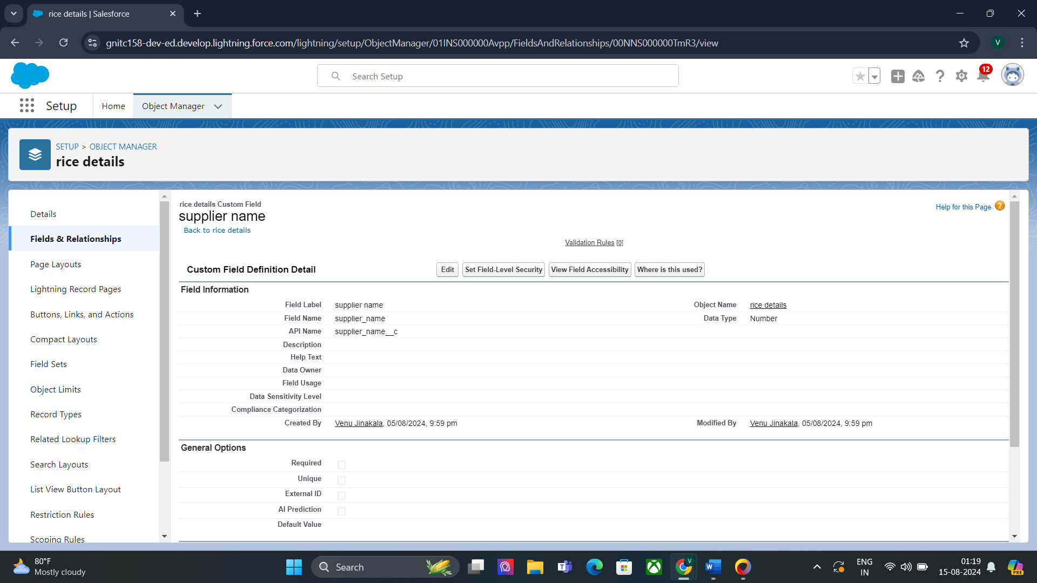

#### Task 15:

#### Creating Fields in rice mill Objects

1. Go to the setup page >> click on object manager >> From drop down click edit for rice mill object.

2. Click on fields & relationship >> click on New.

3. Select Data type as “number" and click Next.

4. Given the Field Label as “ rice price/kg” length as “ 5

5. Field Name will be auto populated, and click on Next>> Next >>Save.

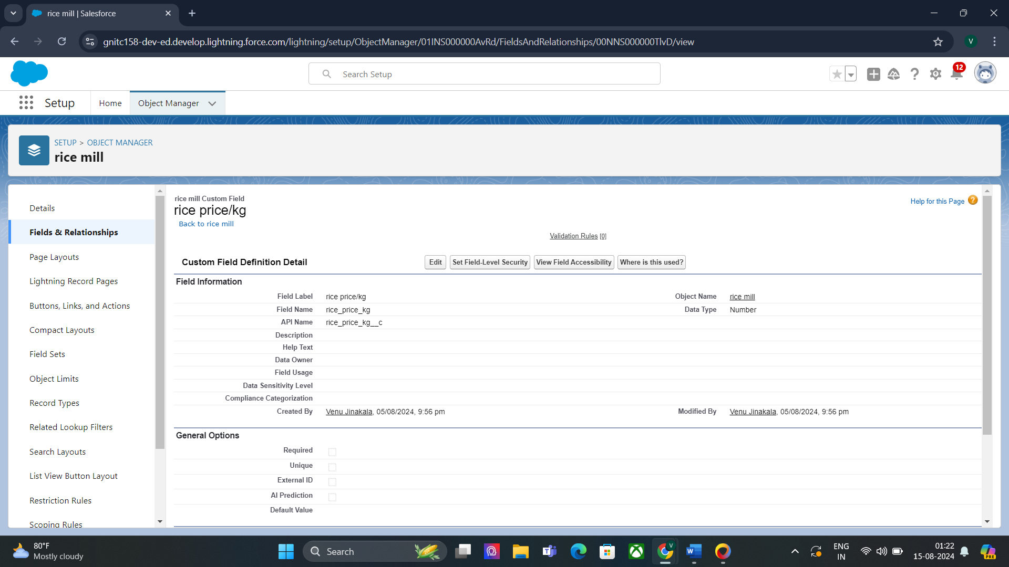

#### Task 16:

#### Creating Fields in consumer Objects

| S.no | Object name | Fields data type |
| --- | --- | --- |
| 1. | consumer | |  |  | | --- | --- | | First name | Text | | Last name | Text | | phone number | phone | |
|  |  | |  |  | | --- | --- | | email | email | | Rice taken by shops | Number (length=5) |  |  |  | | --- | --- | | Rice Type | (Picklist values)  1.basmati  2.normal rice | | Mode of payment | Picklist values  ● Credit card  ● Debit card  ● Net banking  ● UPI  ● Cash | |

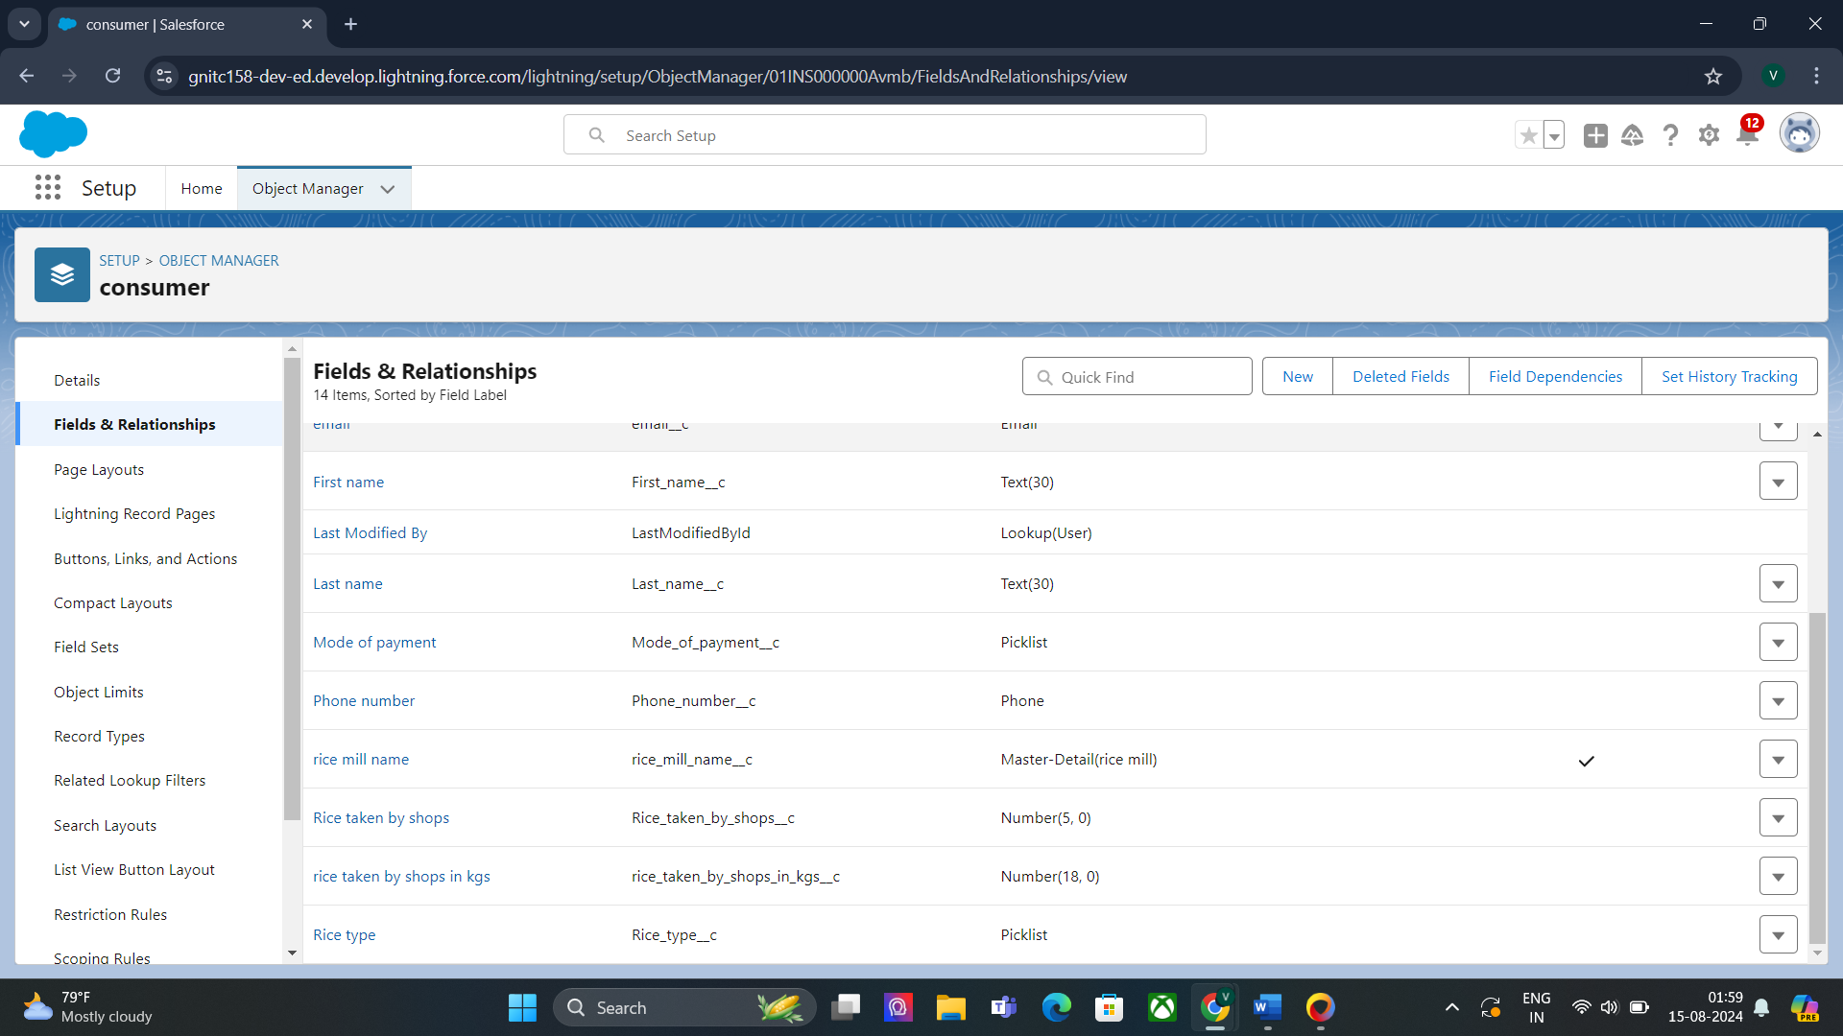

#### Task 17:

#### Creating Cross Object Formula Field in consumer Object

1. Go to setup >> click on Object Manager >> type object name(consumer) in search bar >> click on the object.

2. Click on fields & relationship >> click on New.

3. Select Data type as “Formula” and click Next.

4. Give Field Label and Field Name as “Amount Paid ” and select formula return type as “Number” and click next.

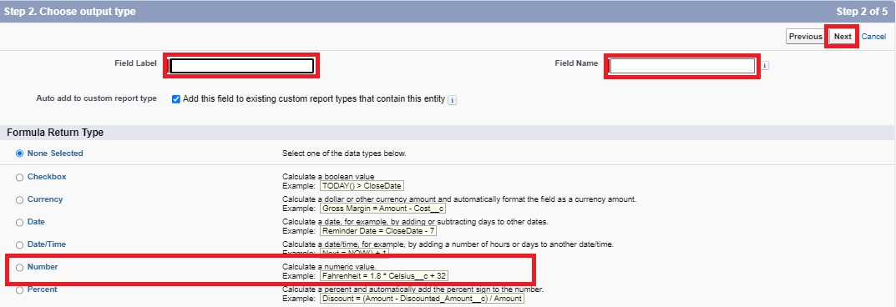

5. Insert fields formula should be :

rice_taken_by_shops__c * rice_mill_name__r.rice_price_kg__c

6. Under Advanced Formula write down the formula and click “Check Syntax” and Save.

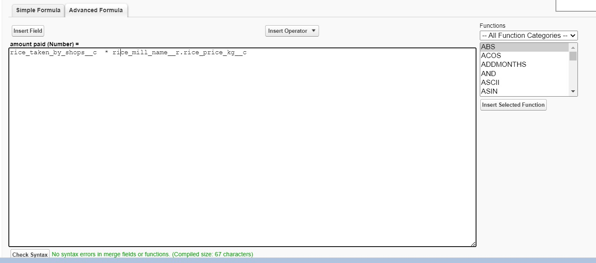

1. Creating the Formula field in consumer Object

Note : check whether that the fields that mentioned in the formula field are created are not , if not go to activity 9 and create that fields mentioned in consumer object

2. Go to setup >> click on Object Manager >> type object name(consumer) in search bar >> click on the object.

3. Click on fields & relationship >> click on New.

4. Select Data type as “Formula” and click Next.

5. Give Field Label and Field Name as “Consumer Name” and select formula return type as “TEXT” and click next.

6. Insert field formula should be : First_Name__c + ' ' + Last_Name__c

7. click “Check Syntax” and Save.



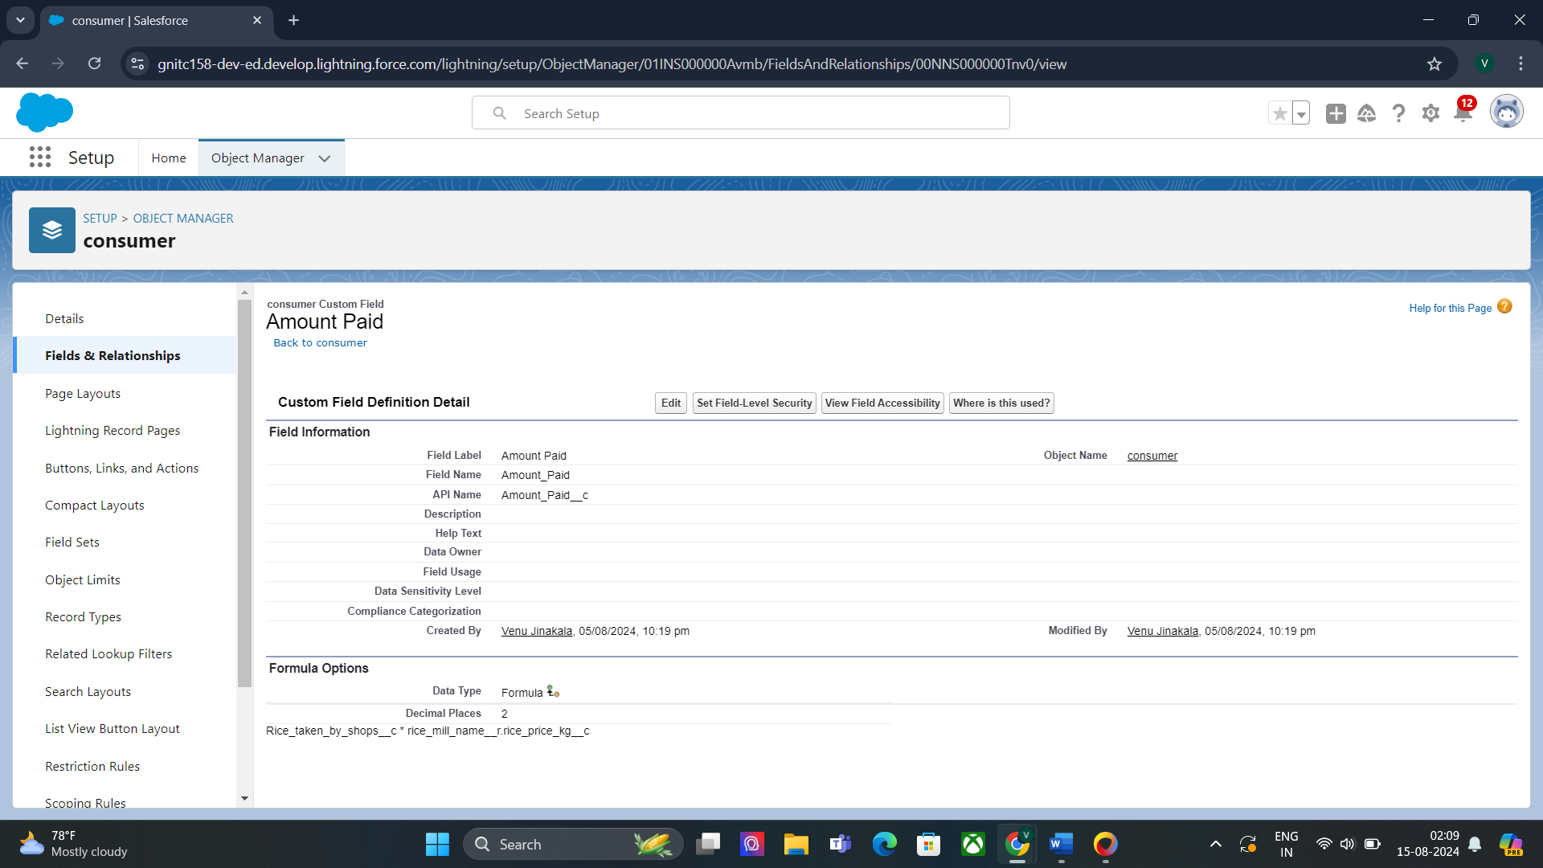

#### **Task 18:**

#### Creating the validation rule

1. Go to the setup page >>click on object manager >> From drop down click edit for consumer object.

2. Click on the validation rule >> click New.

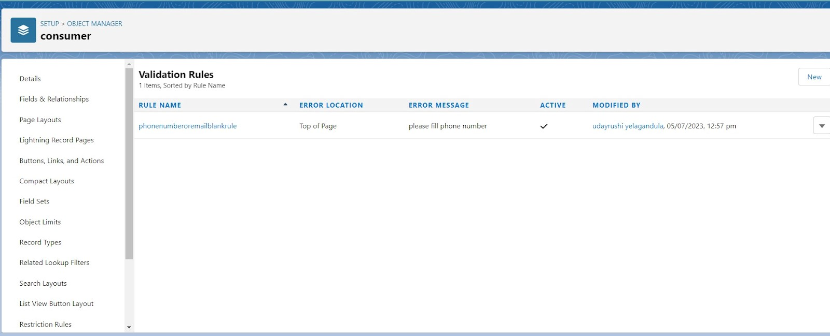

3. Enter the Rule name as “Phonenumberoremailblankrule ”.

4. Enter the description as “phone number and email number should not be blank”.

5. Enter the formula as “OR( ISBLANK( phone_number__c ) , ISBLANK( email__c ) )” and check the syntax.

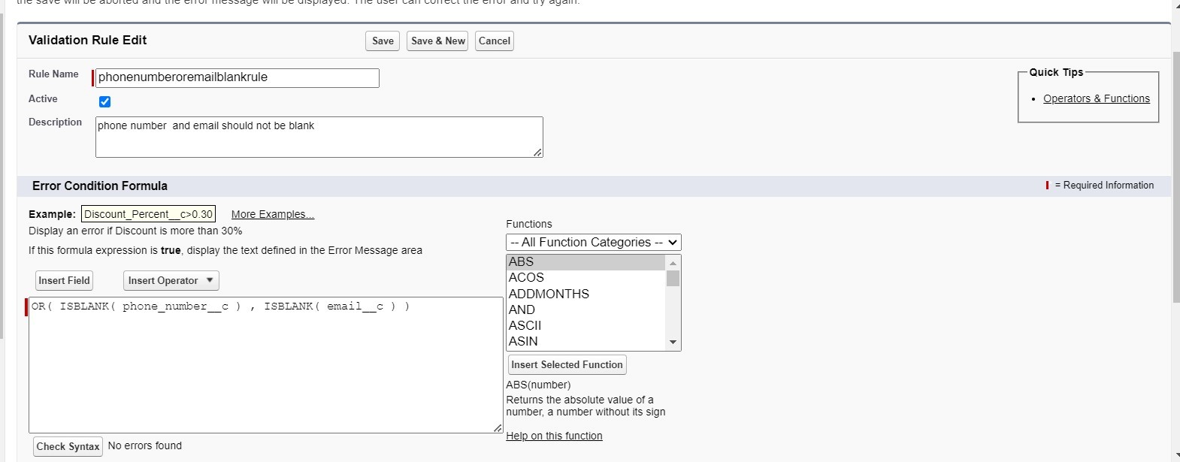

7. Under the error message write as”please fill in your phone number.”

8. Select error location “top of page”.

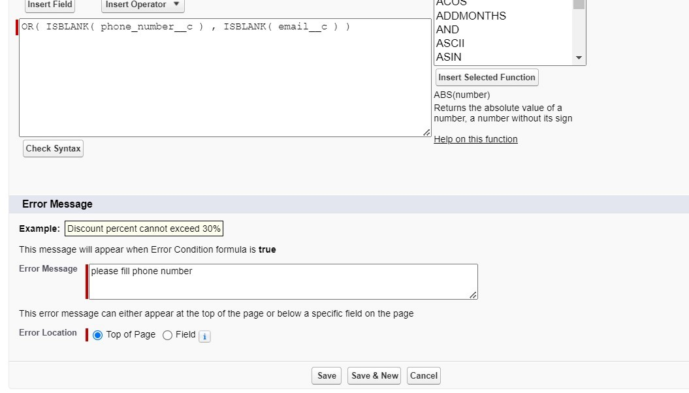

10. Save the validation rule.

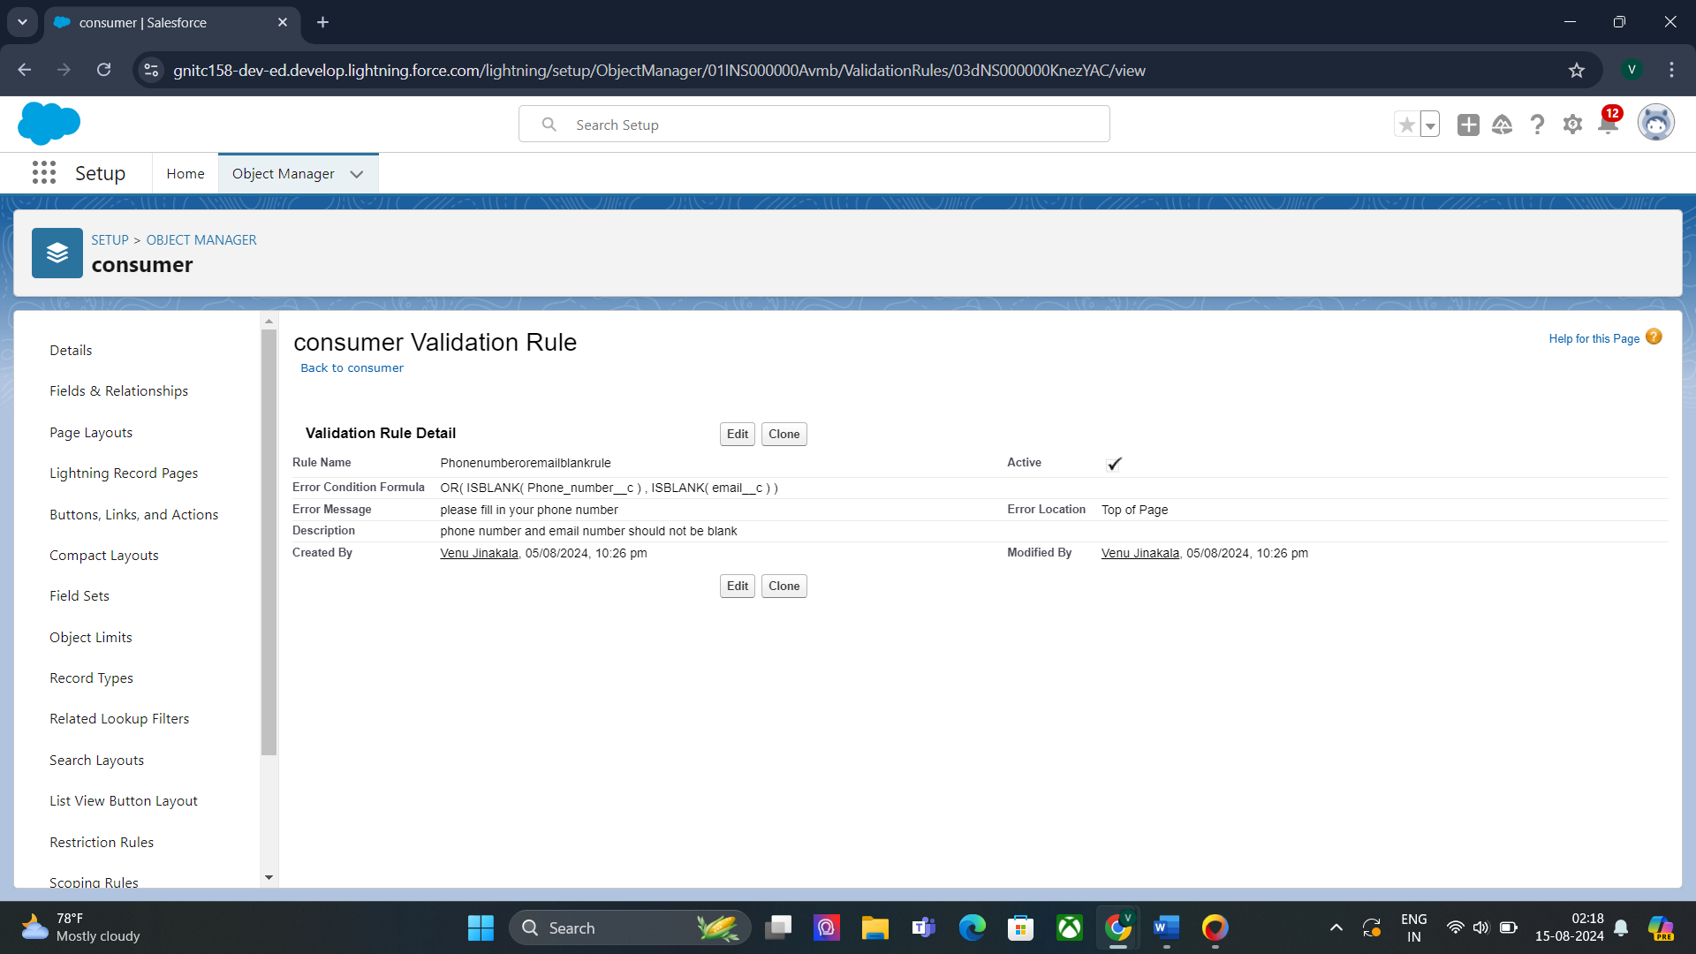

#### Task 19:

#### creating the page layout

To Create a Page layout:

1. Go to Setup >> Click on Object Manager >>Search for the object (consumer) >> From drop down select the object and click on it.

2. Click on Page layout >> Click on New.

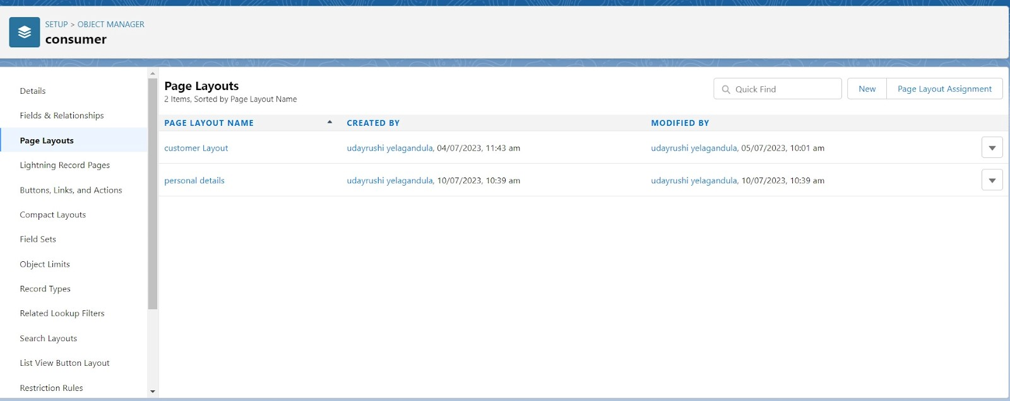

3. Select the existing page layout, and give the page layout name as “consumer layout”, and click save.

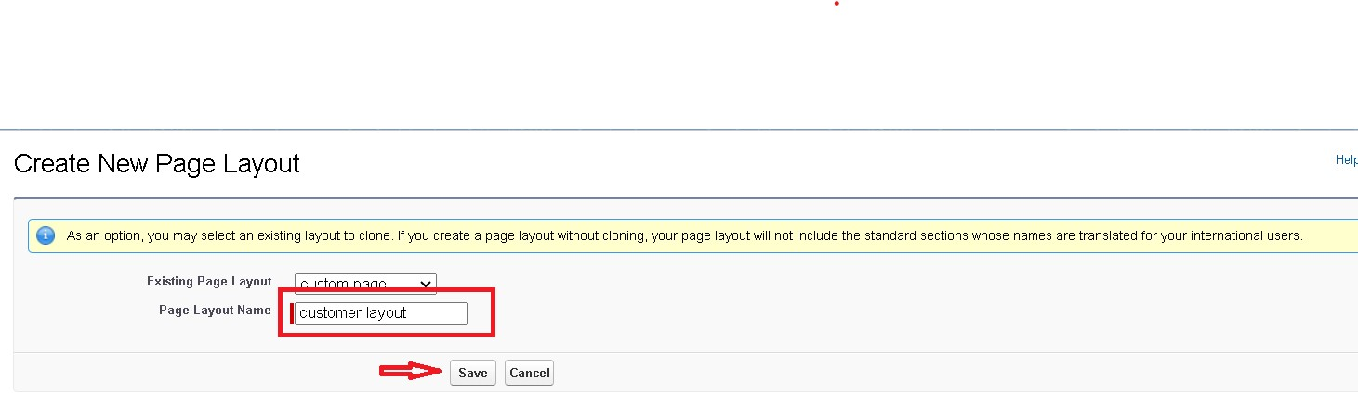

4.

5. Drag and drop the section field to consumer details and create the section. 6. Enter the section name as “Personal details”, - click Ok.

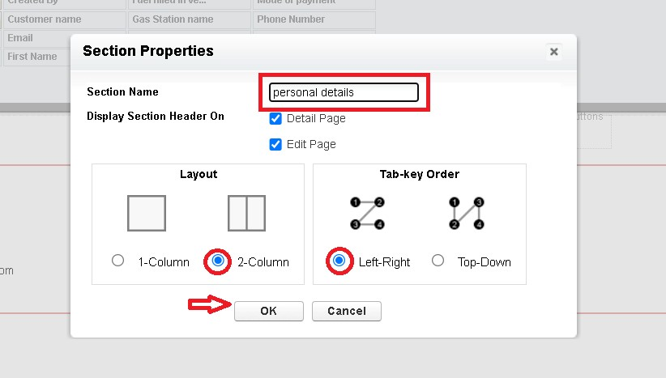

7. Now drag the fields to this section that mentioned , they are

● First name , last name , consumer name , phone number, email, rice mill name.

8. Follow the same process for another two sections as shown above , they are

9. One section is “ rice details ” , drag the fields that are

● Rice taken by shop, rice type.

10. Another section is “Receipt details ”, and drag the fields that are

● Mode of payment , Amount paid.

11. Then Click Save.

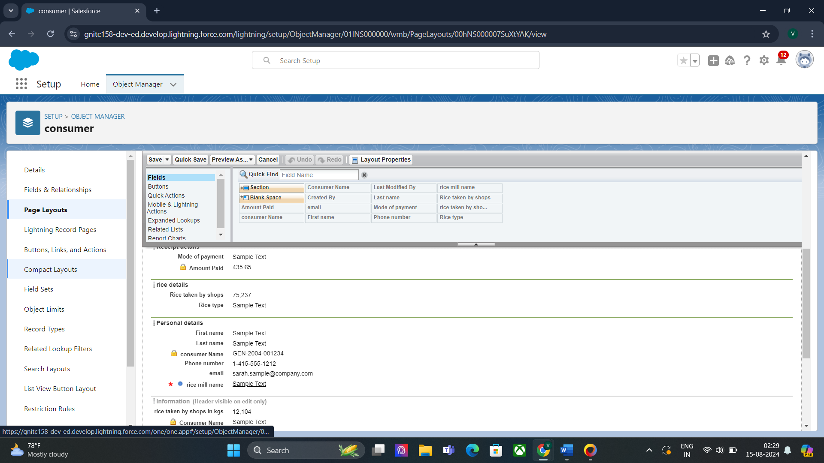

#### Task 20:

#### owner Profile

To create a new profile:

1. Go to setup >> type profiles in quick find box >> click on profiles >> clone the desired profile (Standard User) >>enter profile name (owner) >> Save.

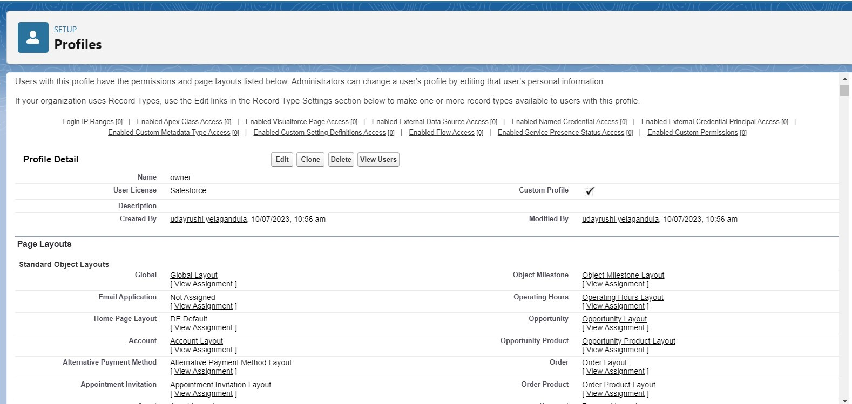

3. Click on Edit >> Scroll down to Custom Object Permissions and Give access permissions for consumers, rice details , rice mill and suppliers objects as mentioned in the below diagram.

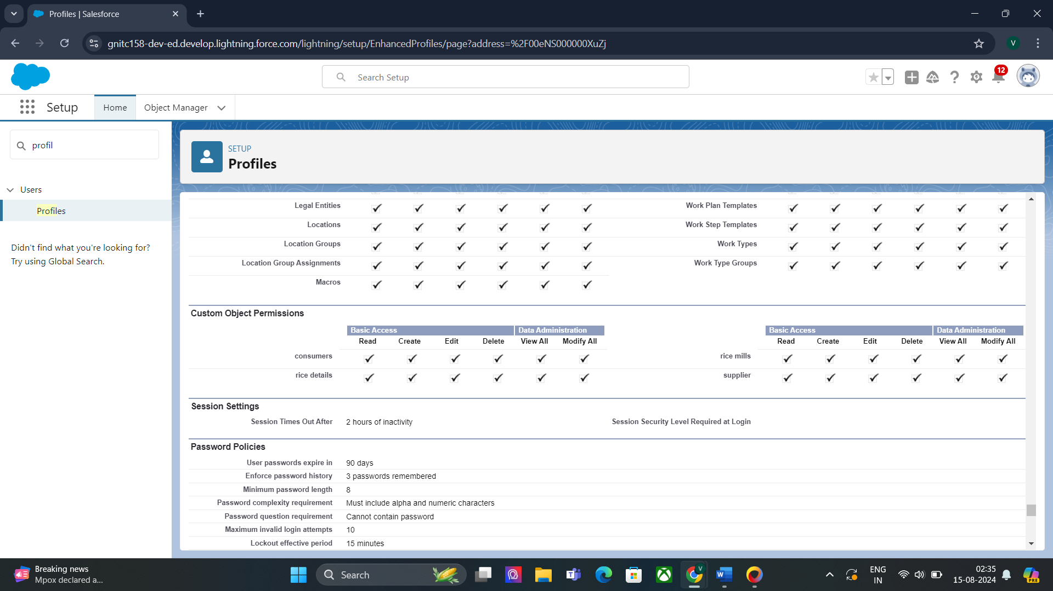

4.

5.Give access and save it.

#### Task 21:

#### employer Profile

1. Go to setup >> type profiles in quick find box >>click on profiles >> clone the desired profile (Standard Platform User) >> enter profile name (employer) >> Save.

2. While still on the profile page, then click Edit.

3. Select the Custom App settings as default for the rice mill.

4. Scroll down to Custom Object Permissions and Give access permissions for consumer, rice details , rice mill and suppliers objects as mentioned in the below diagram.

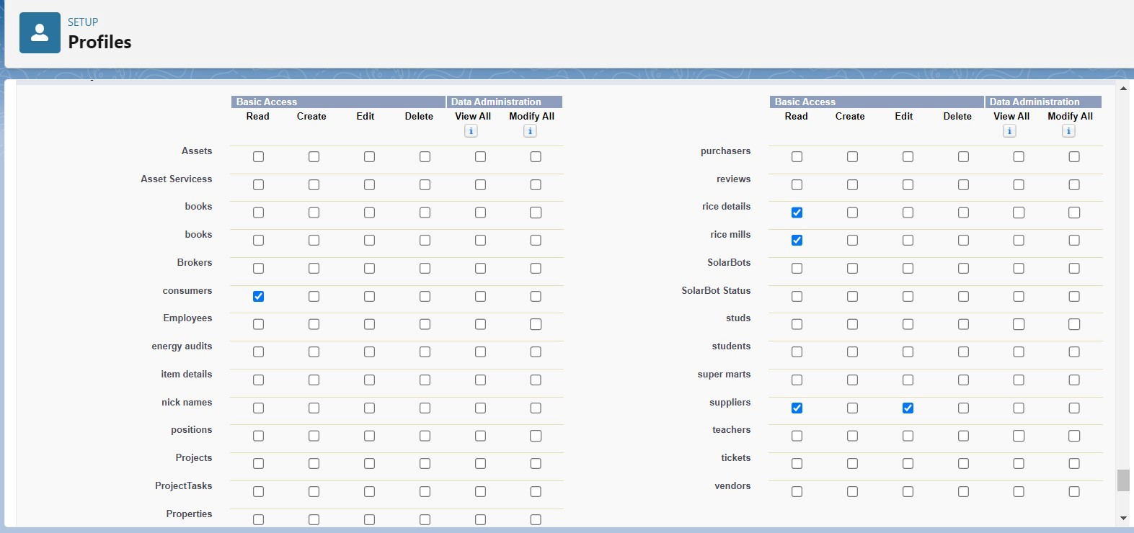

5. And click save.

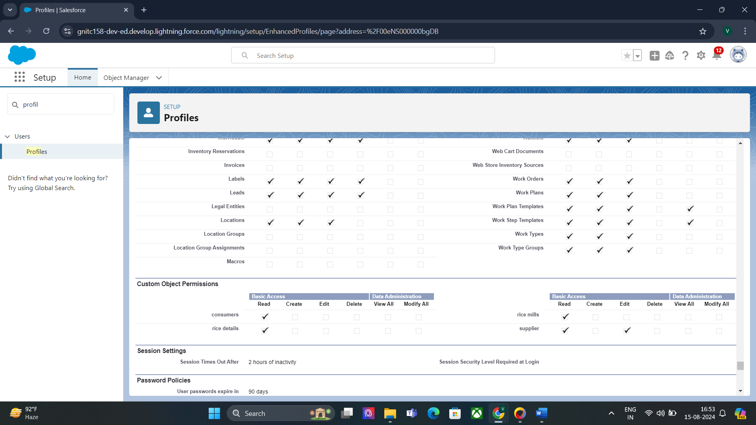

#### Task 22:

#### worker Profile

1. Go to setup >> type profiles in quick find box >> click on profiles >> clone the desired profile (Standard Platform User) >> enter profile name (worker) >> Save.

2. While still on the profile page, then click Edit.

3. Select the Custom App settings as default for the rice mill.

4. Scroll down to Custom Object Permissions and Give access permissions for consumer, rice details , rice mill and suppliers objects as mentioned in the below diagram.

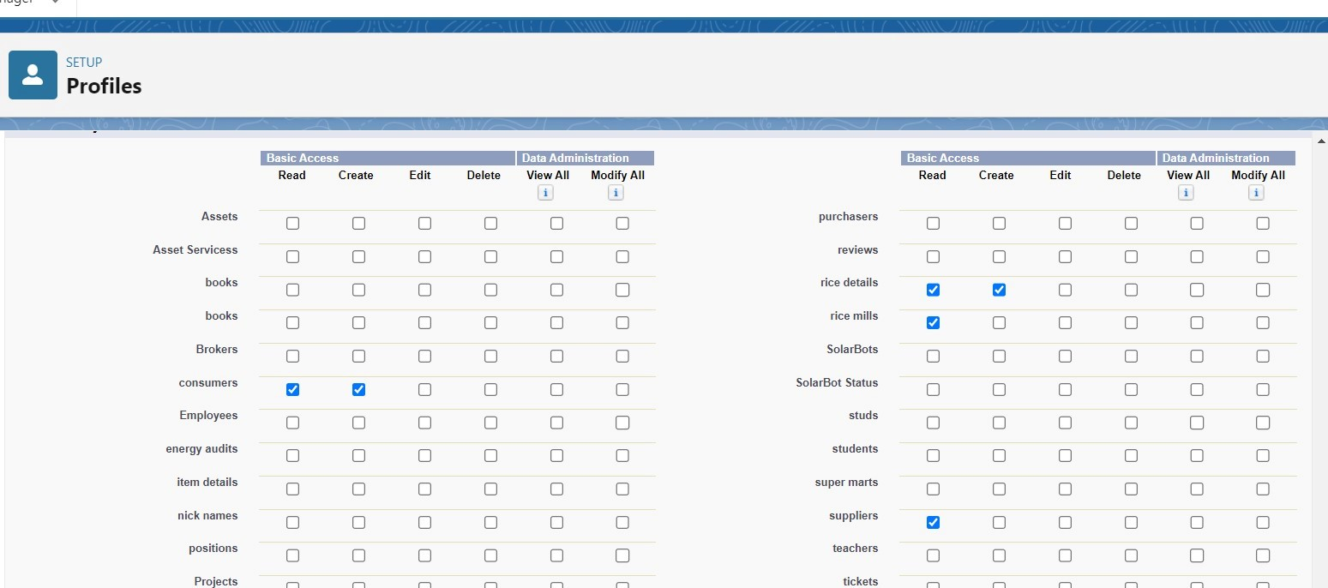

5. And click save.

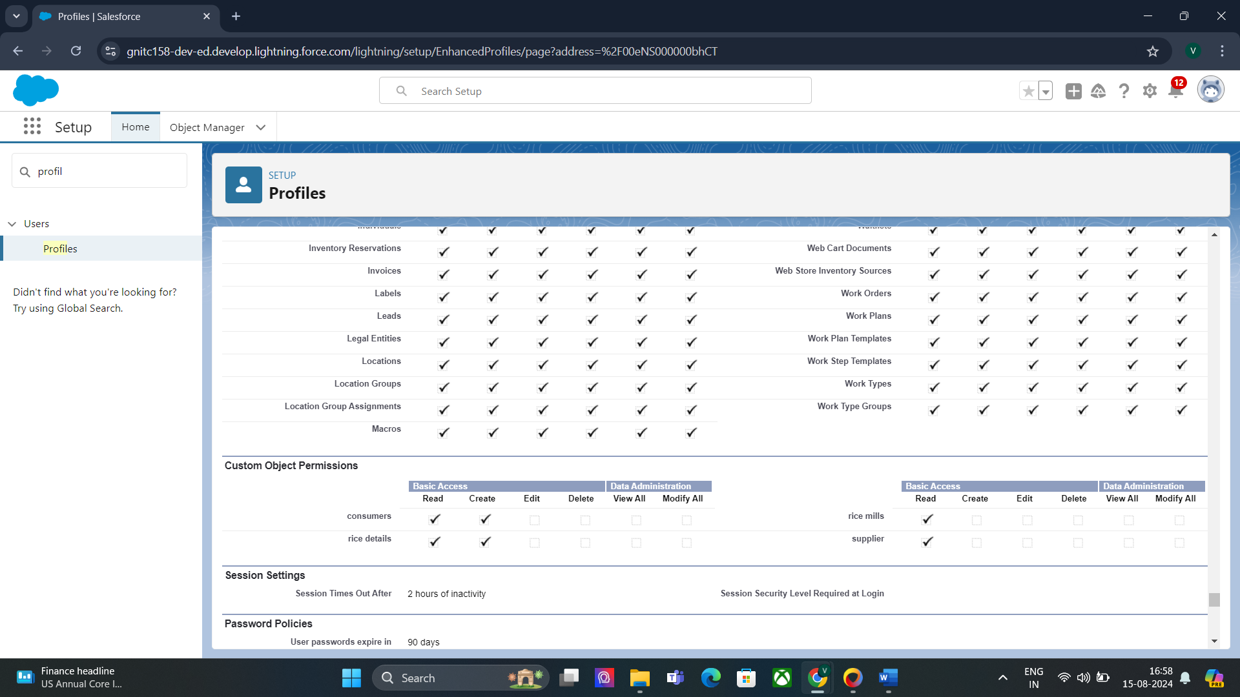

#### Task 23:

#### Creating owner Role

Creating owner Role:

1. Go to quick find >> Search for Roles >> click on set up roles.

2. Go to quick find >> Search for Roles >> click on set up roles.

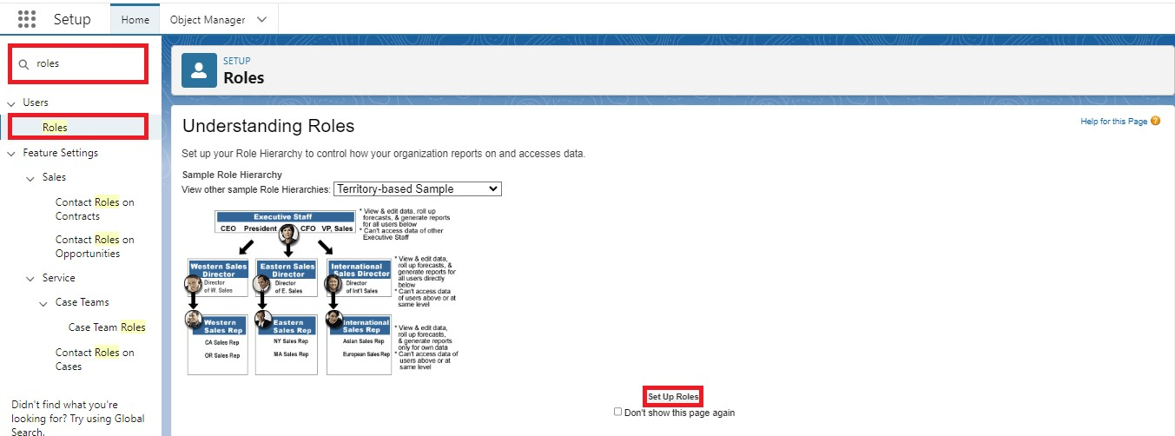

3. Click on Expand All and click on add role under whom this role works.

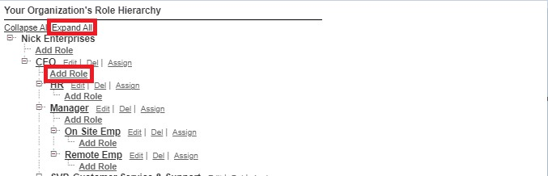

4. Give Label as “owner” and Role name gets auto populated. Then click on Save.

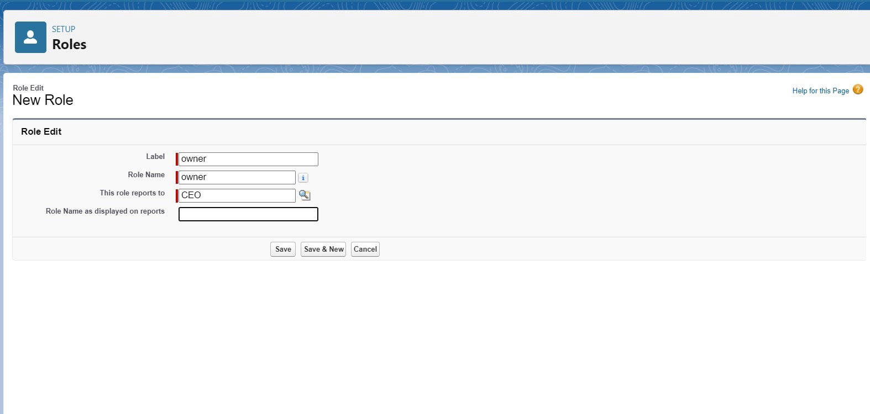

5. Click and save it.

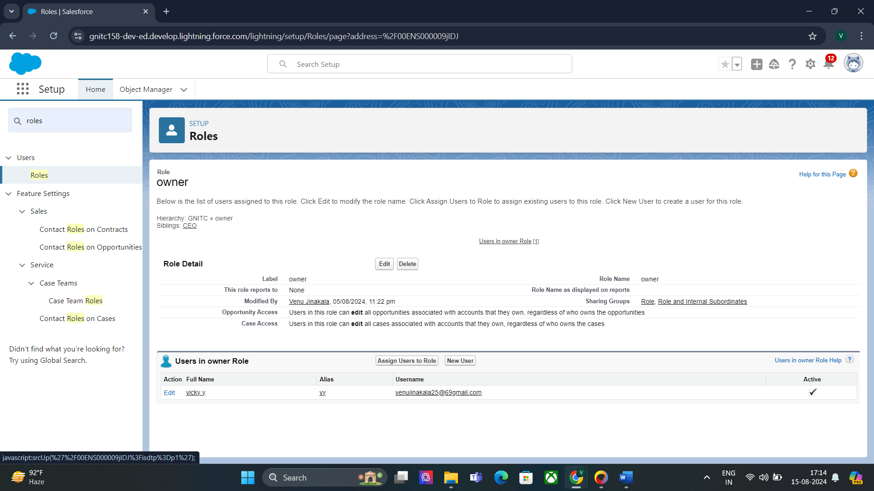

#### Task 24:

#### Creating employer roles

Creating another two roles under manager

1. Go to quick find >>Search for Roles >>click on set up roles.

2. Click plus on CEO role, and click add role under owner.

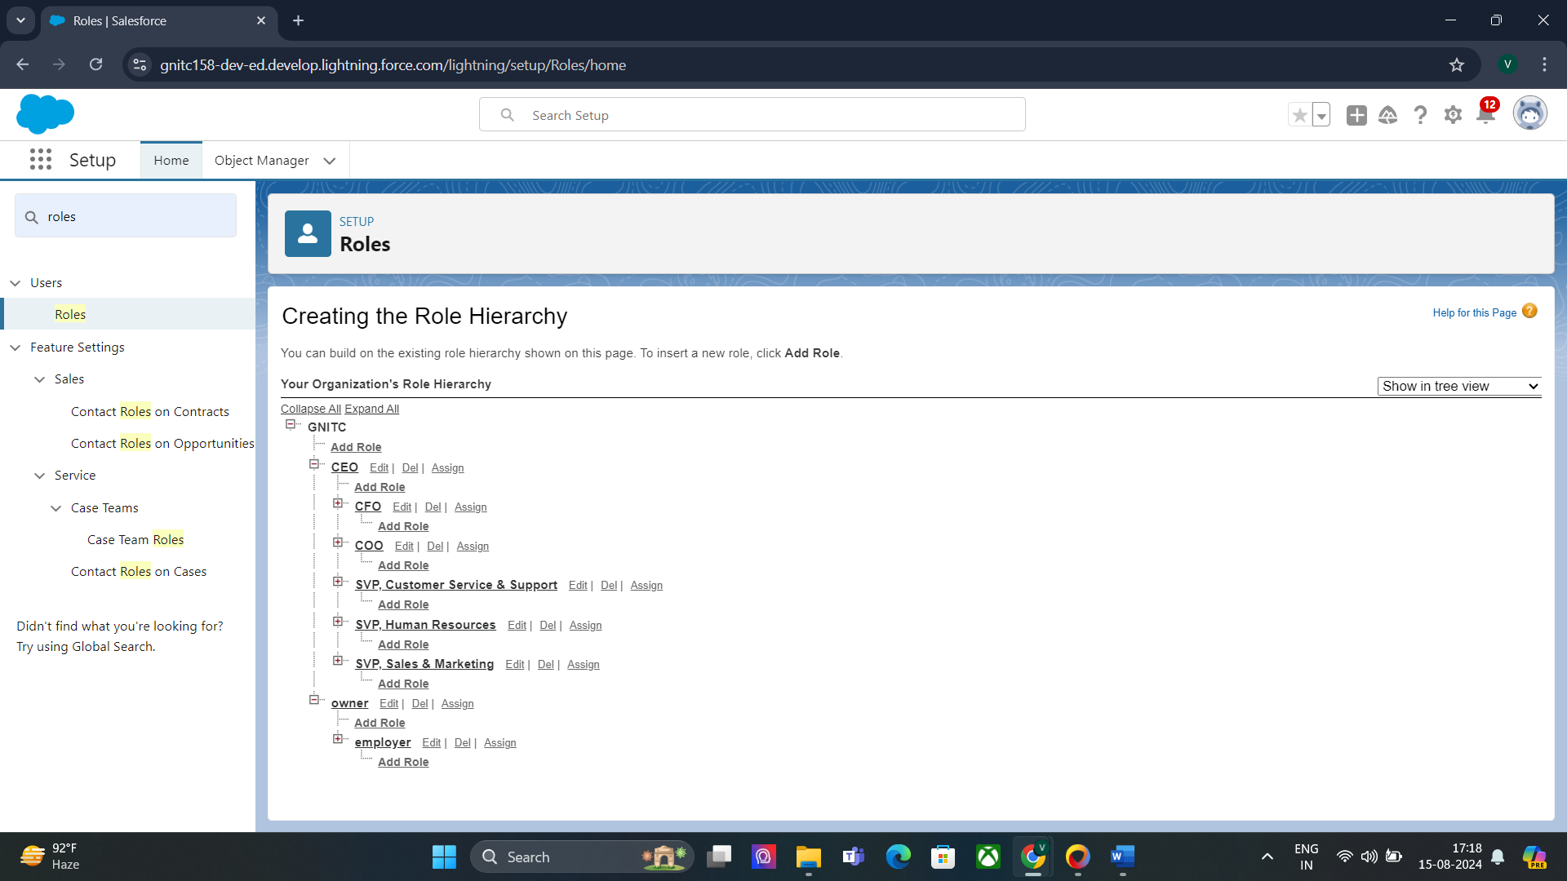

4. Give Label as “employer” and Role name gets auto populated. Then click on Save.

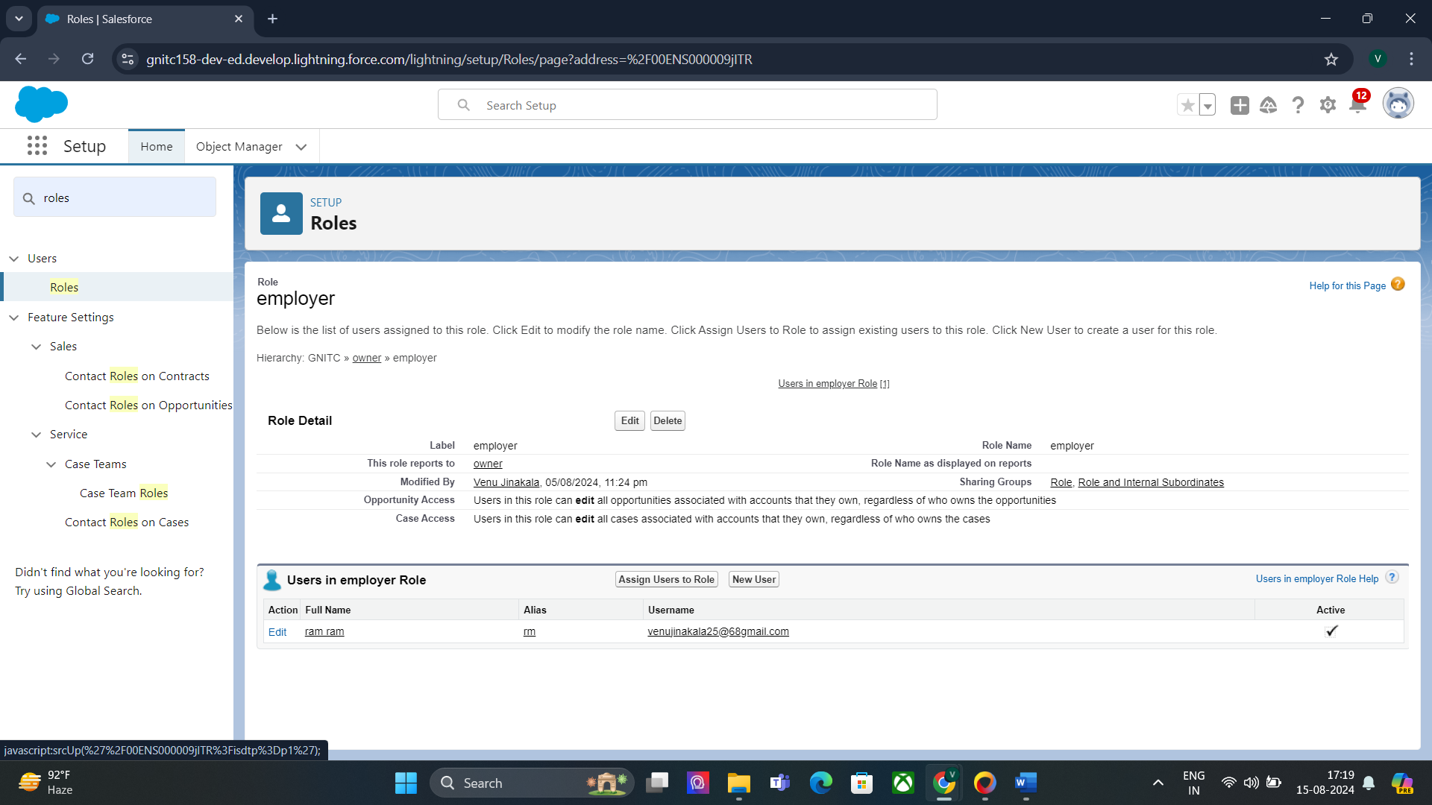

5. Repeat the same steps, for another role.

6. Click plus on CEO role, and click plus on owner, and click add role under employer.

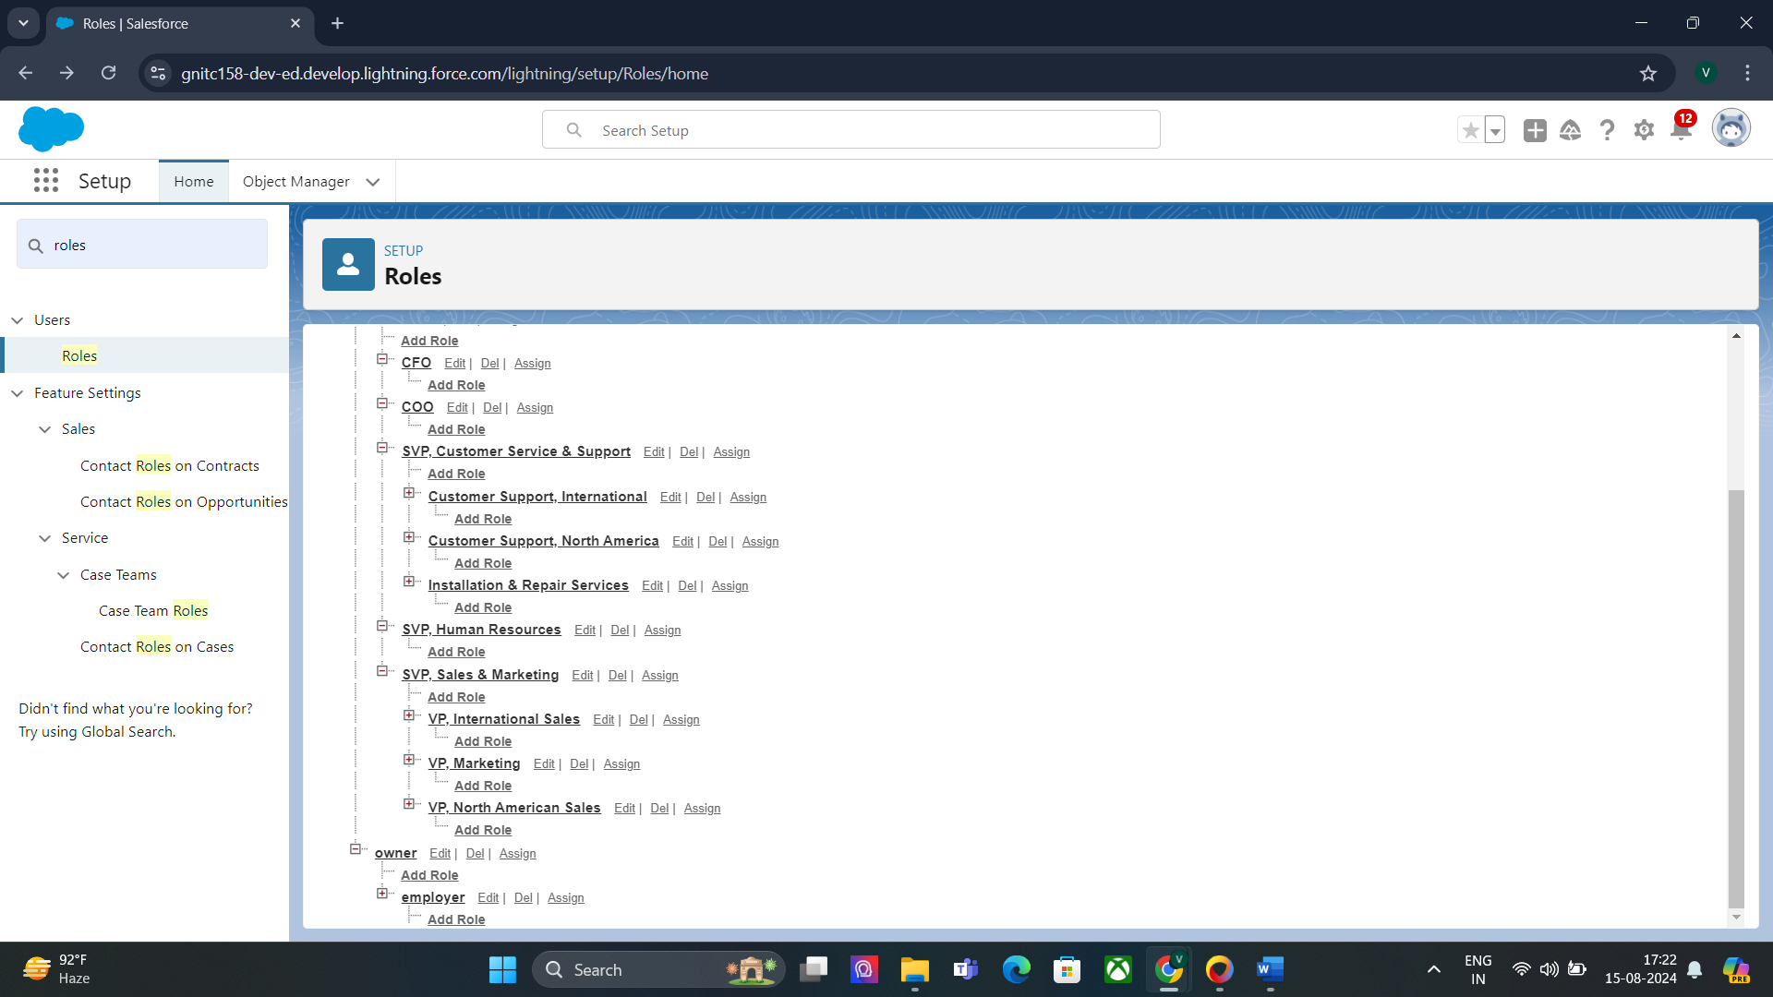

7. give Label as “worker” and Role name gets auto populated. Then click on Save.

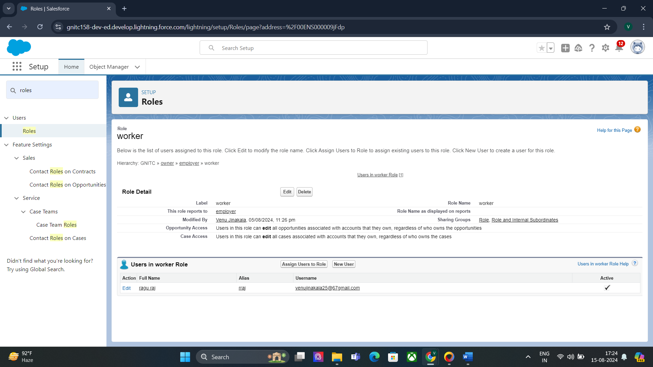

#### Task 25:

#### Create User

1. Go to setup >> type users in quick find box >> select users >> click New user.

2. Fill in the fields

3. First Name : vicky

4. Last Name : y

5. Alias : Give a Alias Name

6. Email id : Give your Personal Email id

7. Username : Username should be in this form: text@text.text

8. Nick Name : Give a Nickname

9. Role : owner

10. User license : Salesforce

11. Profiles : owner.

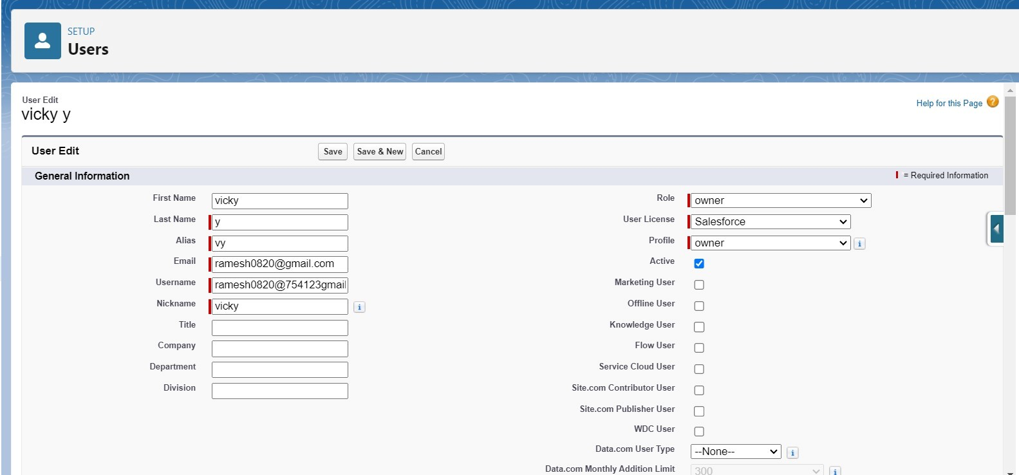

12. Save it.

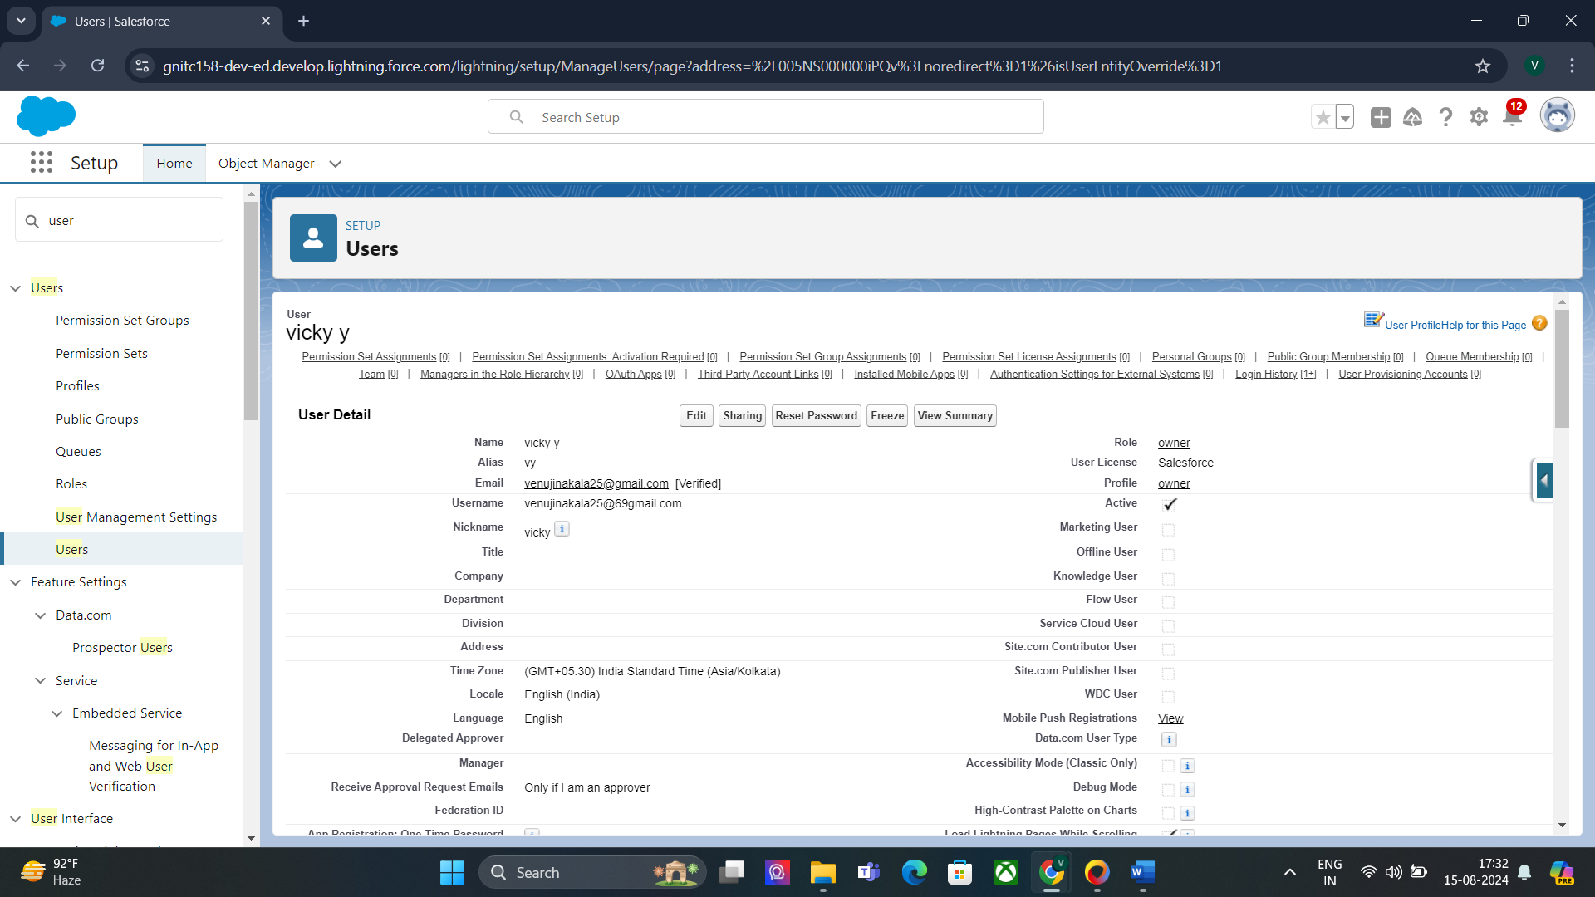

#### Task 26:

#### creating another users

1. Go to setup ? type users in quick find box ? select users ? click New user.

2. Fill in the fields

3. First Name : ram

4. Last Name : ram

5. Alias : Give a Alias Name

6. Email id : Give your Personal Email id

7. Username : Username should be in this form: text@text.text

8. Nick Name : Give a Nickname

9. Role : employer

10. User license : Salesforce platform

11. Profiles : standard platform user.

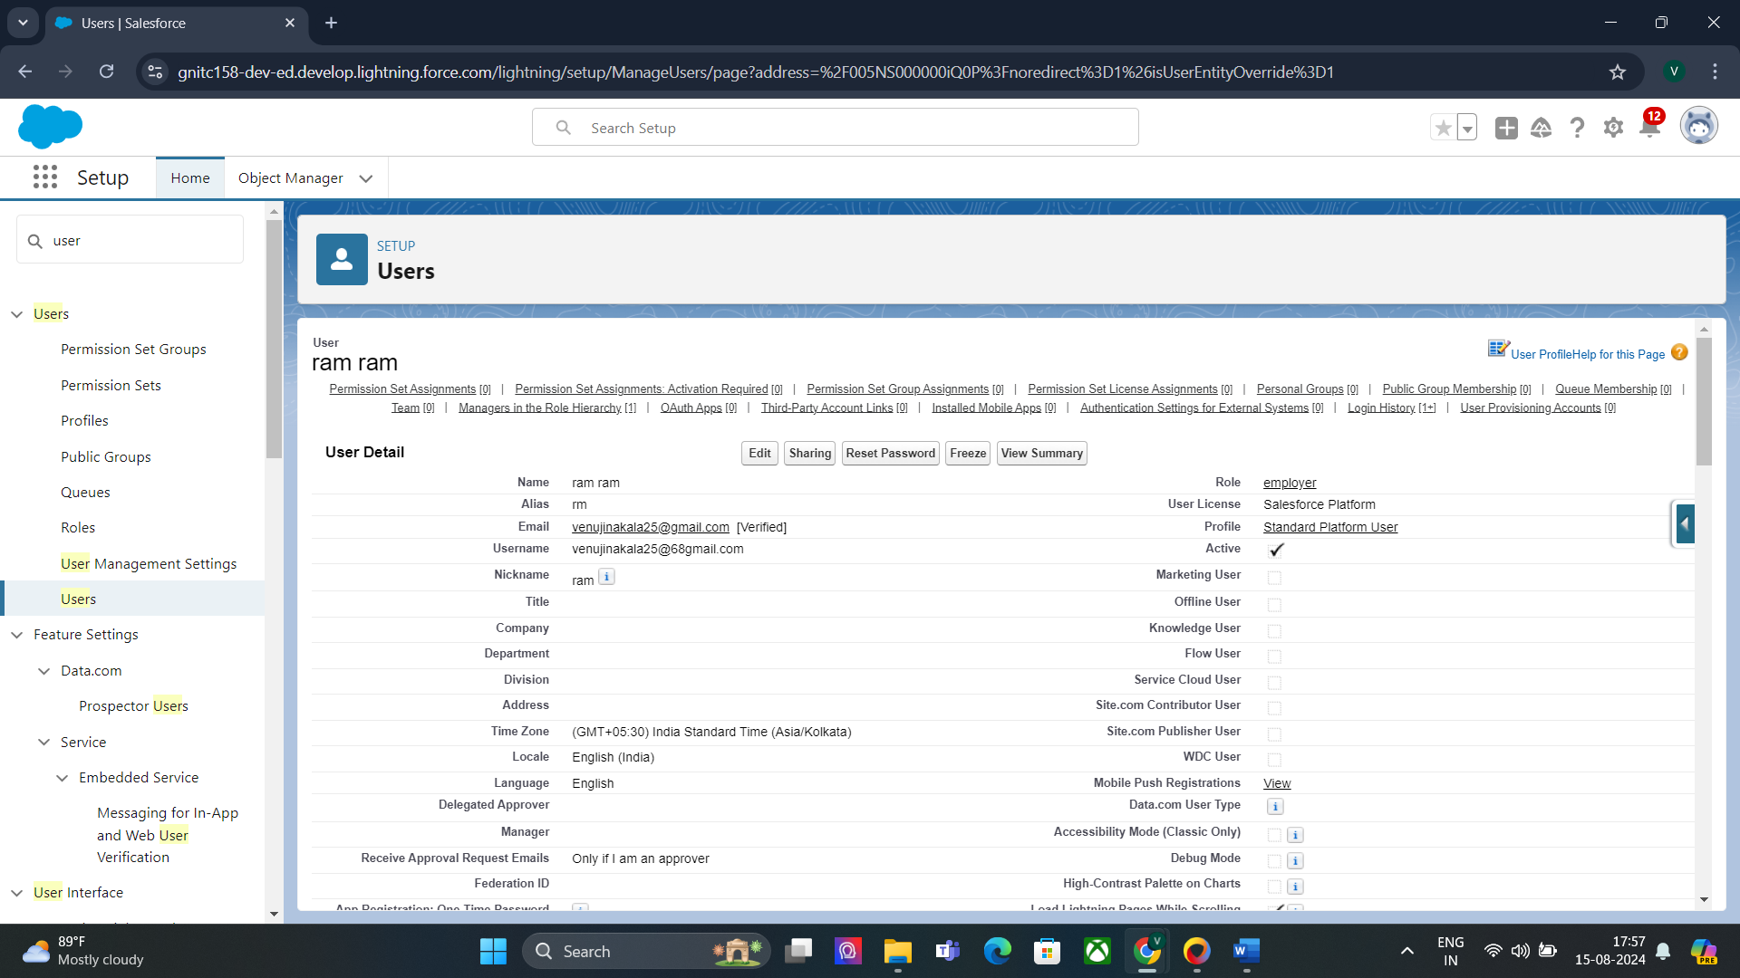

#### Task 27:

#### Create Another User

1. Go to setup ? type users in quick find box ? select users ? click New user.

2. Fill in the fields

3. First Name : ragu

4. Last Name : raj

5. Alias : Give a Alias Name

6. Email id : Give your Personal Email id

7. Username : Username should be in this form: text@text.text

8. Nick Name : Give a Nickname

9. Role : worker

10. User license : Salesforce platform

11. Profiles : standard platform user.

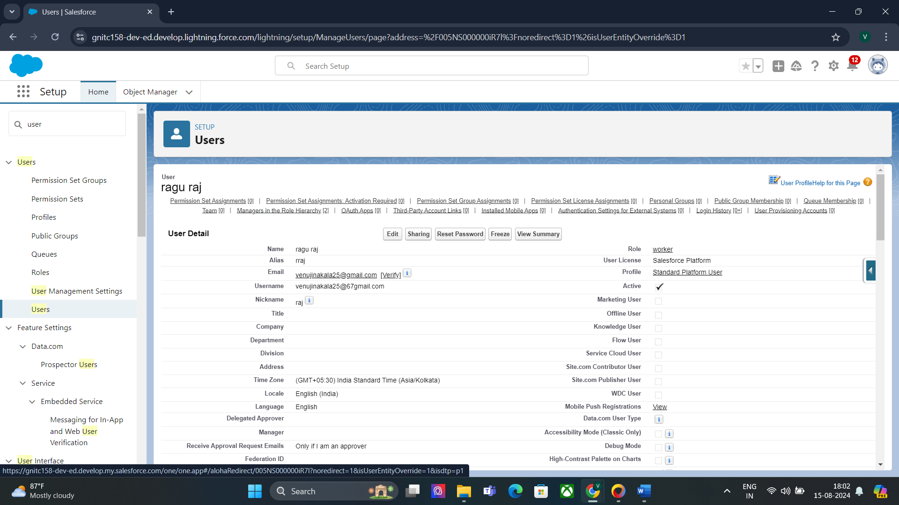

#### Task 28:

#### Creating OWD setting

1. Go to setup >> type “sharing settings ” in quick search >> Click edit.

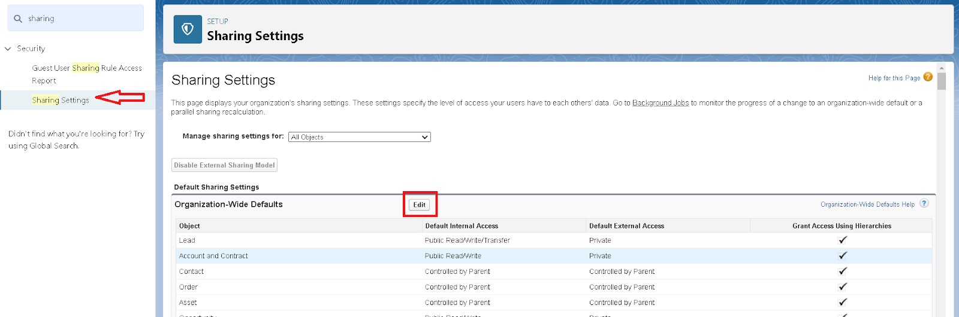

2. Scroll down, change the default internal access to “ public read-only” for rice mill and supplier object.

3. Click save.

4. Extra information, By these every profile has their own access, according to their profile.

5. But in our case we created roles and given the roles in such a way that the owner can see employer and worker records , and the employer can see the worker records.

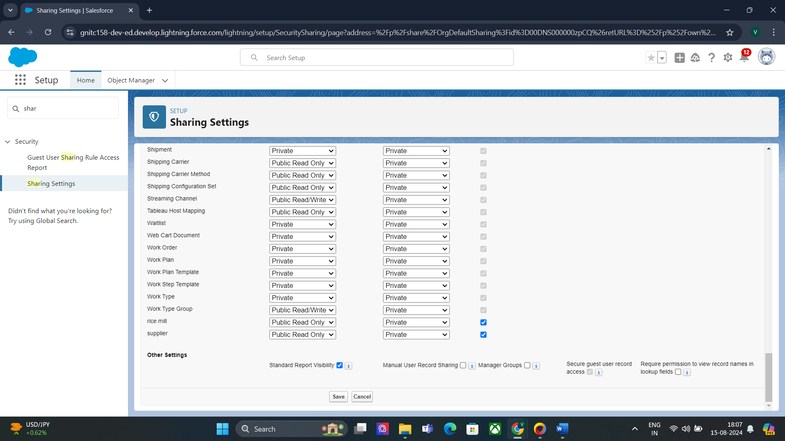

#### Task 29:

#### Create Report

Note : Before creating a report, create the latest “10” records in consumer objects.

Try to fill every field in each record for better experience. To create Records : Click on consumers tab >> click on New >> Enter the details and click on Save. Repeat these steps to create "10" records.

1. Go to the app >>click on the reports tab

2. Click New Report.

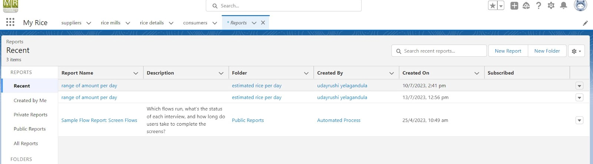

3. select for report type, search for “rice mill with consumers” click on it. And click on start report.

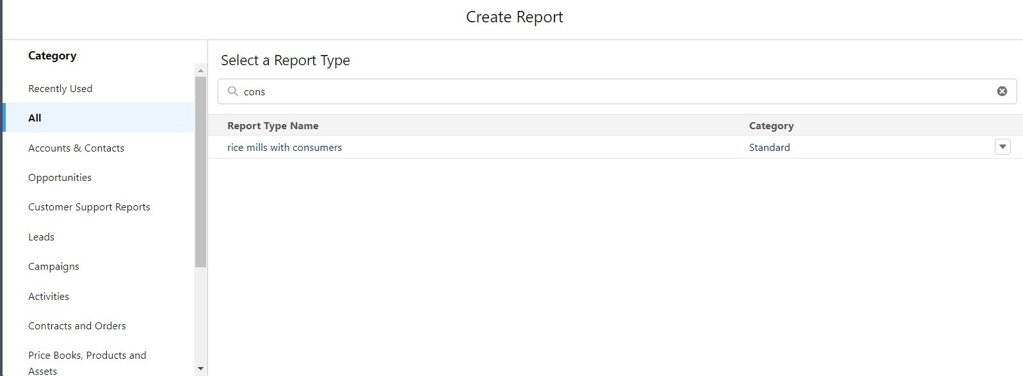

1. Their outline pane is opened already, select the fields that are mentioned below in the column section.

1.consumer name

2.rice type

3.rice price/kg

4.mode of payments

5.amount paid

2. Remove the unnecessary fields.

3. Select the fields that are mentioned below in the GROUP ROWS section.

1. Rice taken by shops

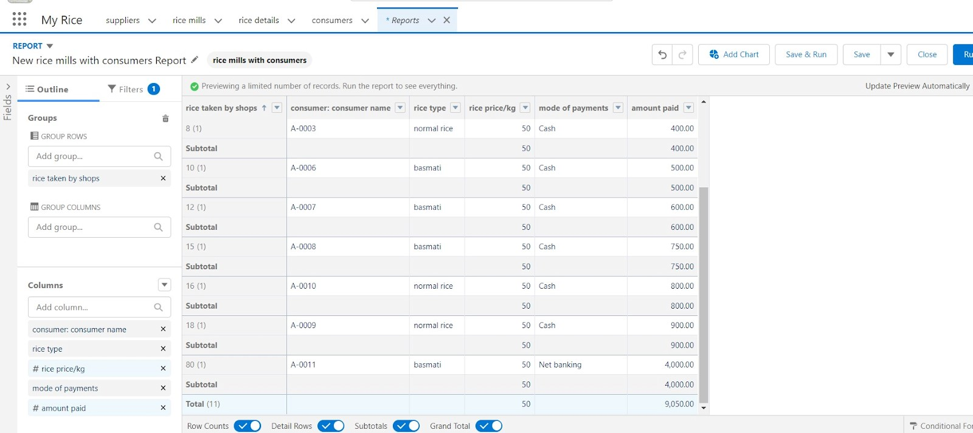

4.Click save and run and save the report as “range of amount per day”.and save it.

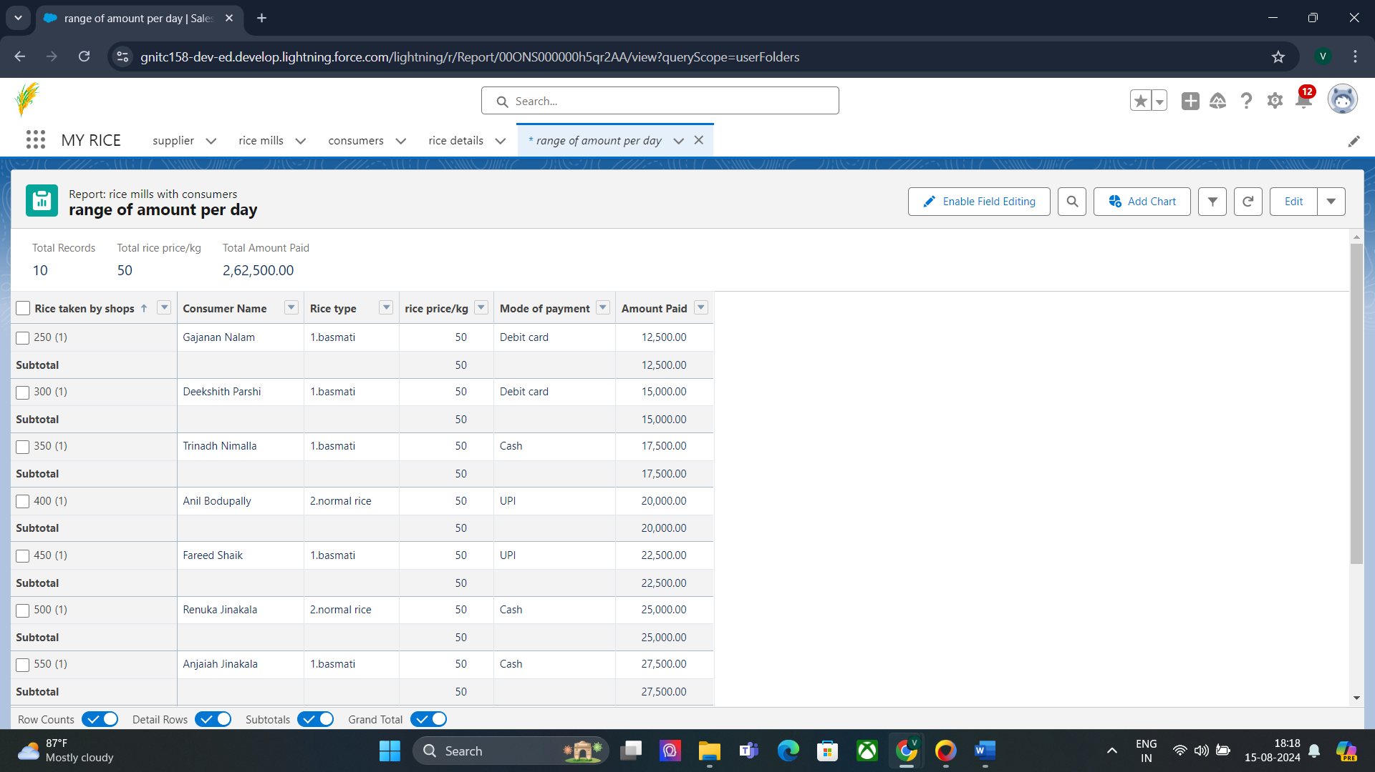

#### Task 30:

#### Sharing report to owner

1. Click edit drop down and select subscribe option.

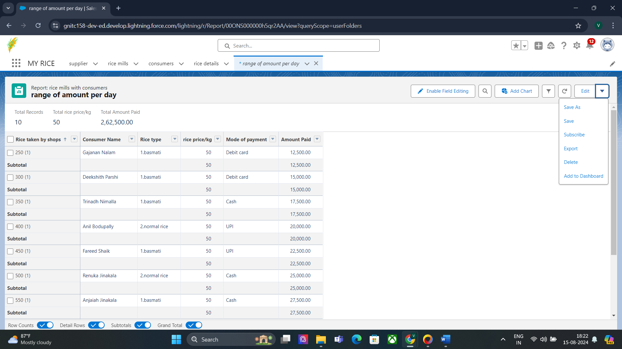

2. Follow as per below image.

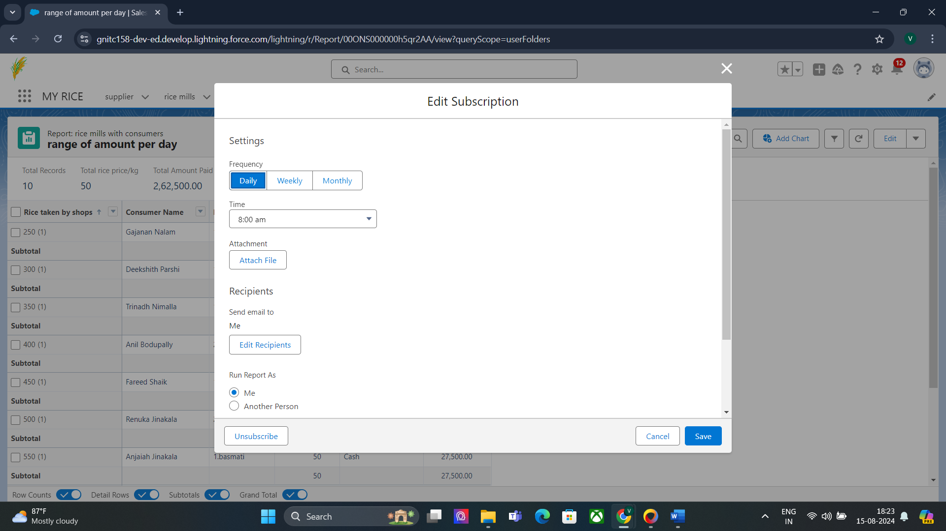

3. After selecting the run report as a “another person” select your personal account or whom you want to send that mail to.

4. Click save.

NOTE: The owner gets daily email notification of that rice mill report.so that he can see all data remotely as shown below.

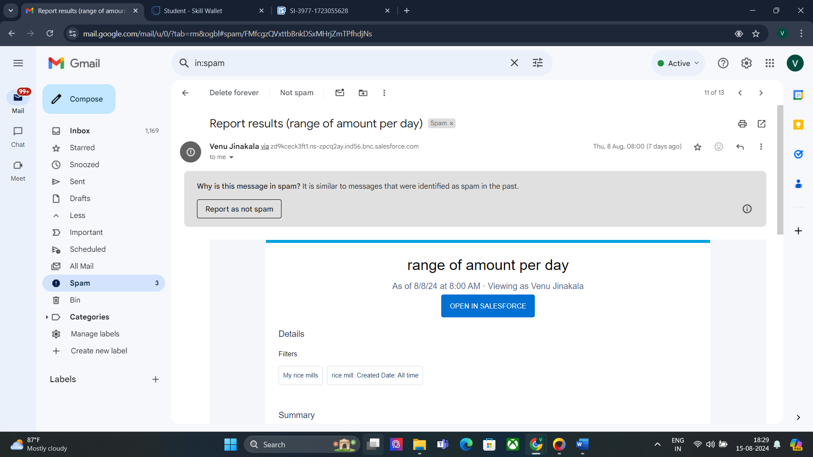

#### Task 31:

#### create a report folder

1. Click on the app launcher and search for reports.

2. Double click on the report, “ reports tab” will be auto populated in the navigation bar.

3. Click on the report tab, click on the new folder.

4. Give the Folder label as “estimated rice per day ”, Folder unique name will be auto populated.

5. Click save.

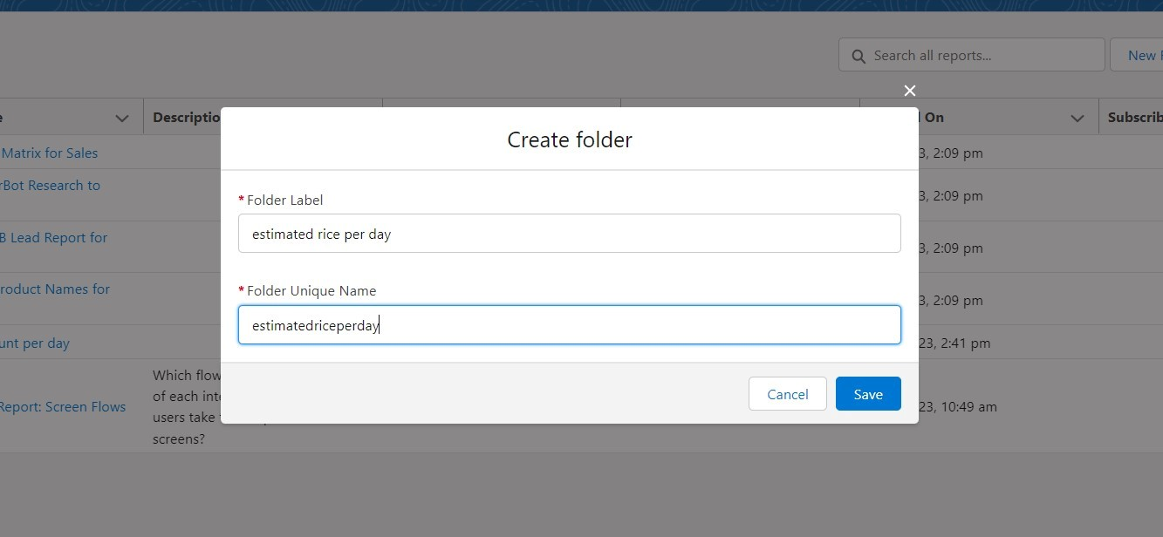

1.navigate to app launcher and click reports on that.

2.click all reports.

3. Select the range of amount per day drop down in that click move.

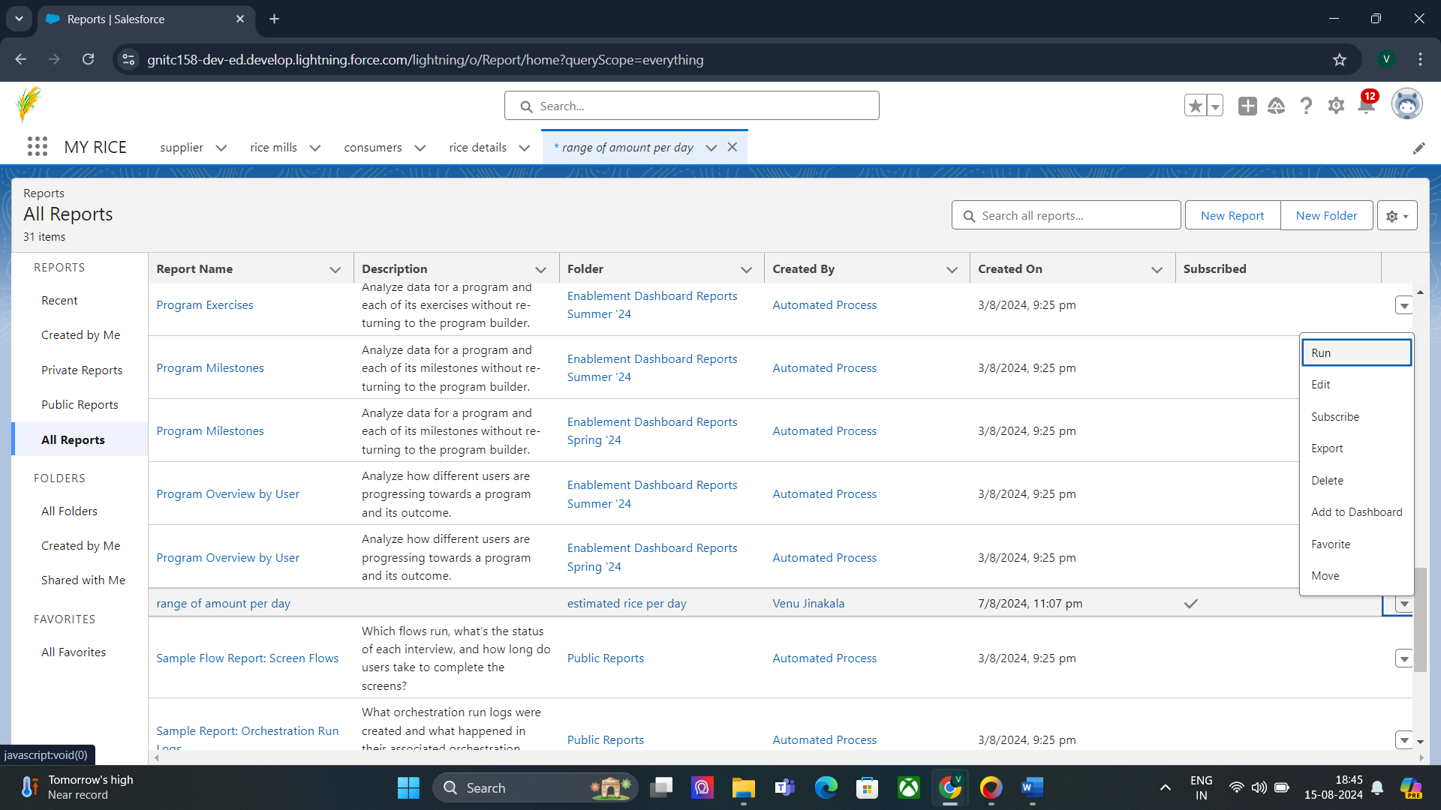

5. Select estimated rice per day folder and select folder.

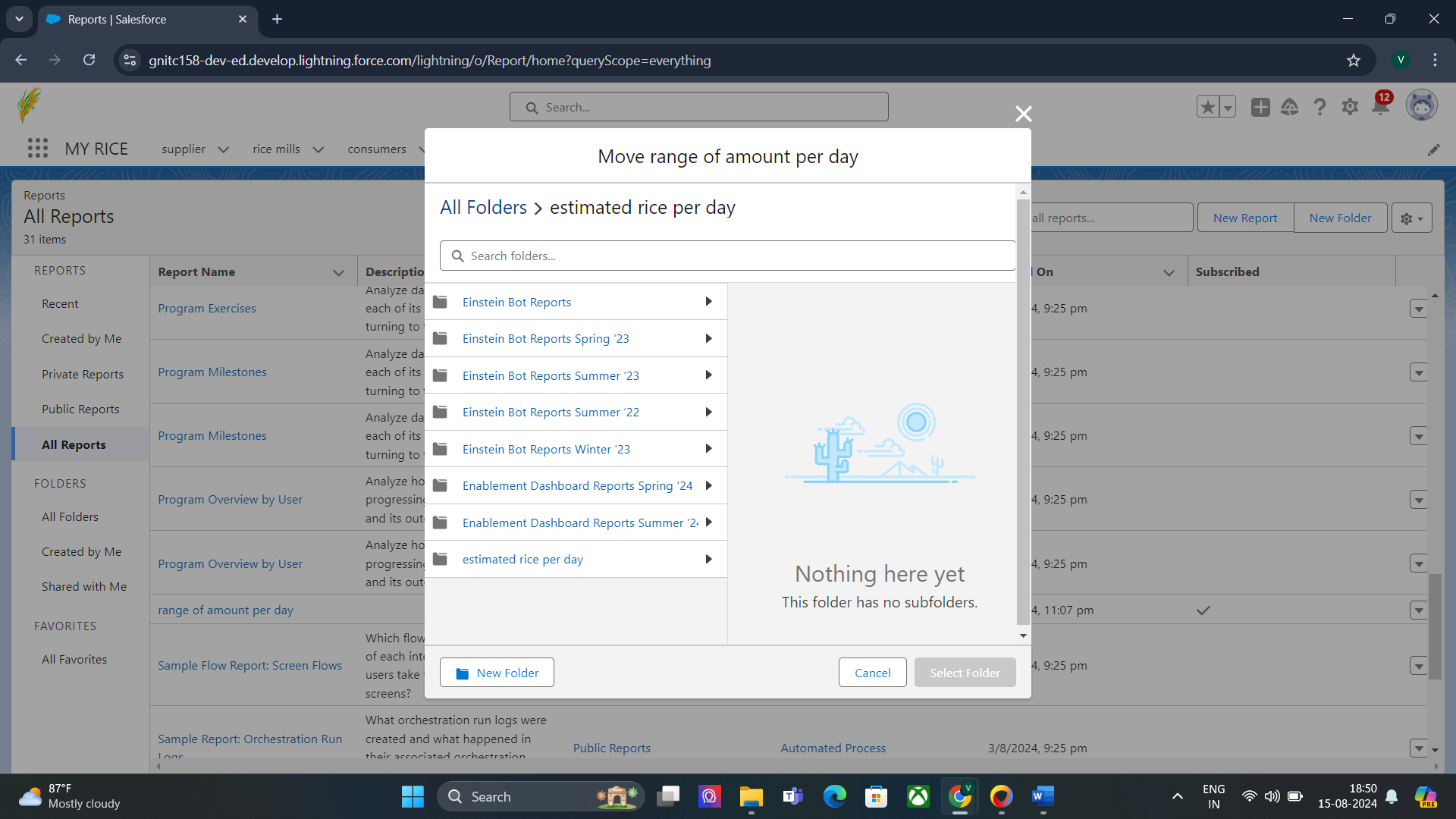

Note: if you want to see the report which you have created then go to reports - all folders - estimated rice per day - your report will appear in this way.

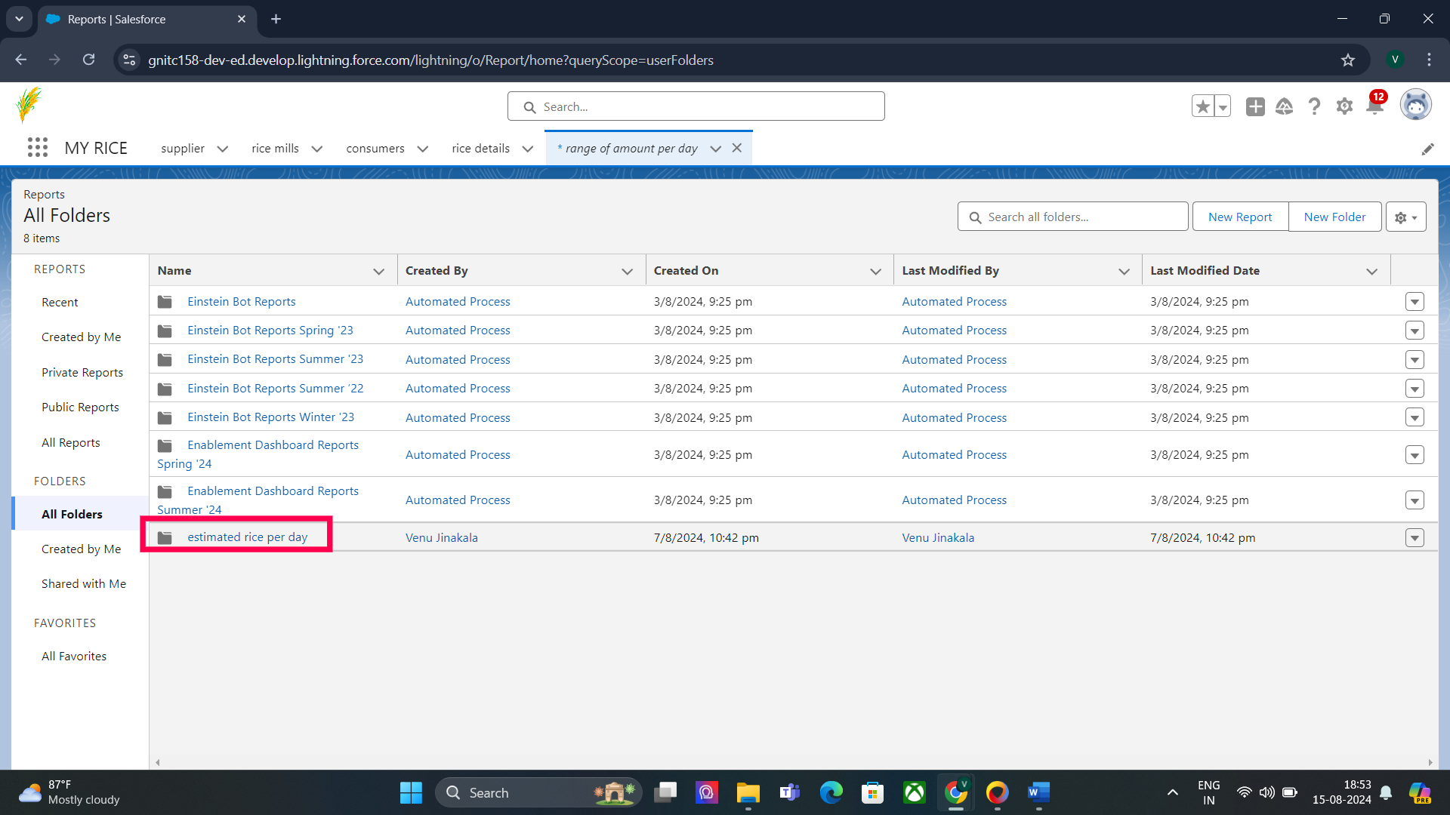

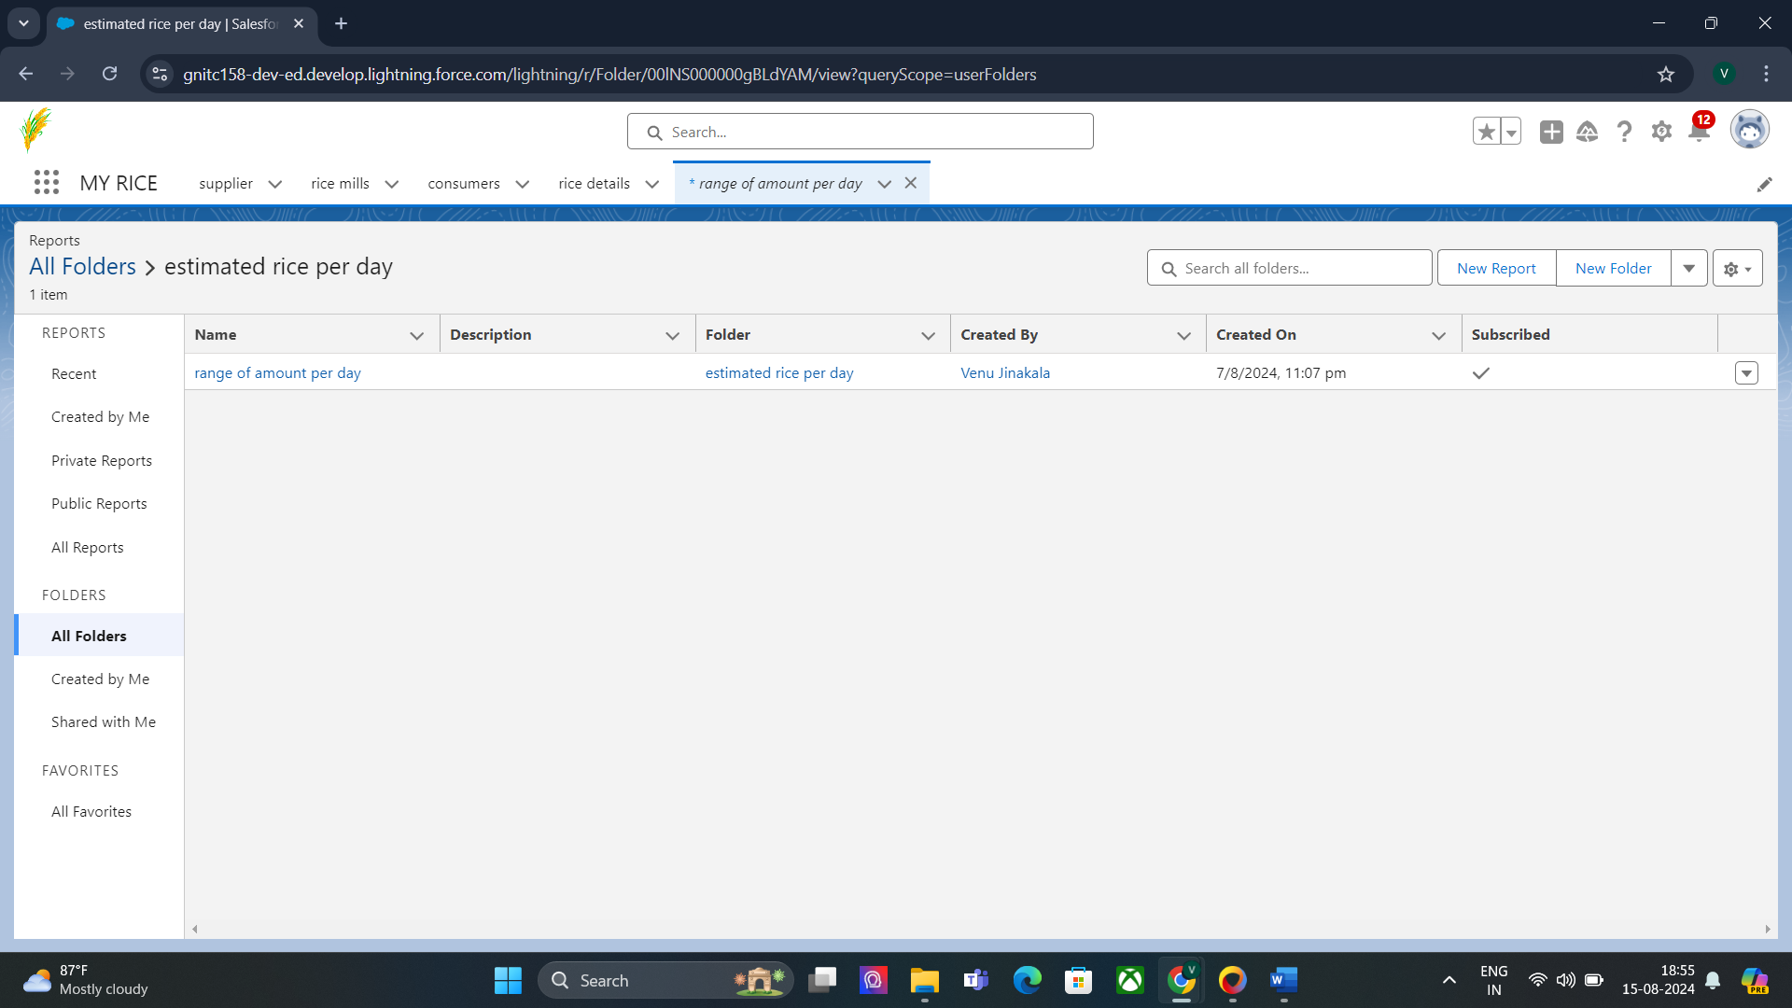

#### Task 32:

#### Create Dashboard Folder

1. Click on the app launcher and search for the dashboard.

2. Click on the dashboard tab.

3. Click the new folder, give the folder label as “ amount data dashboard”.

4. Folder unique names will be auto populated.

5. Click save.

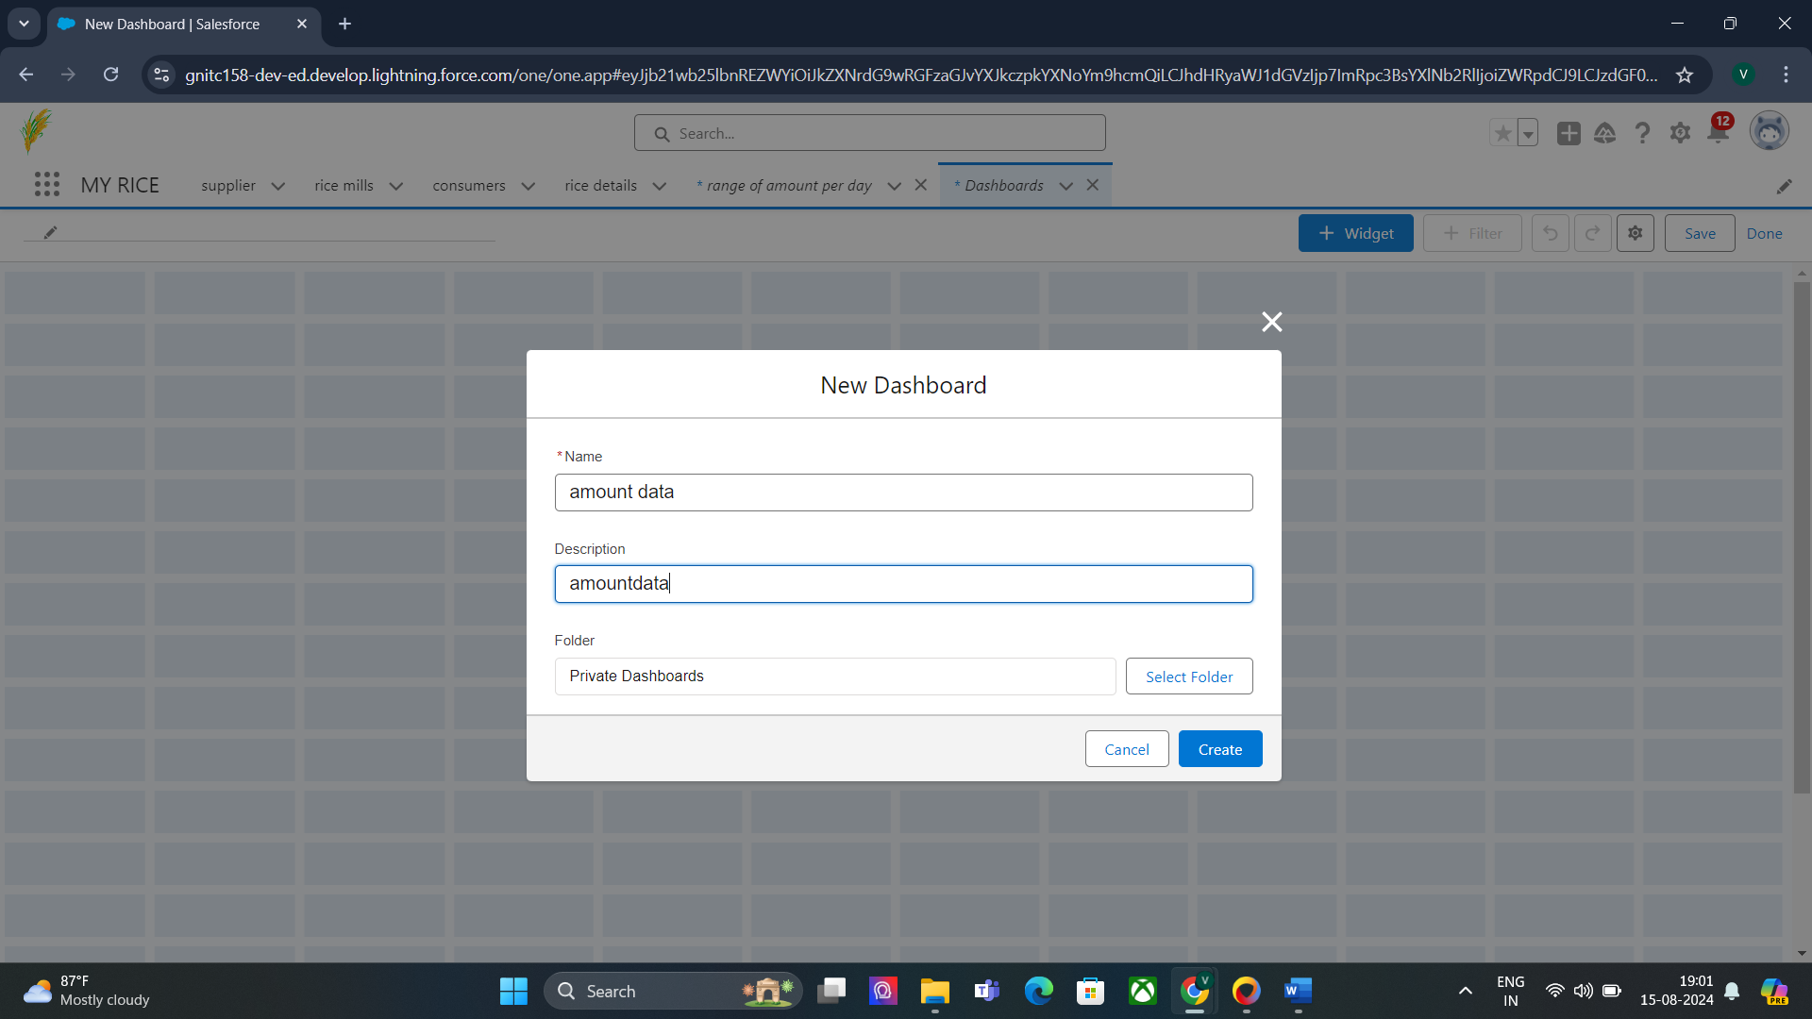

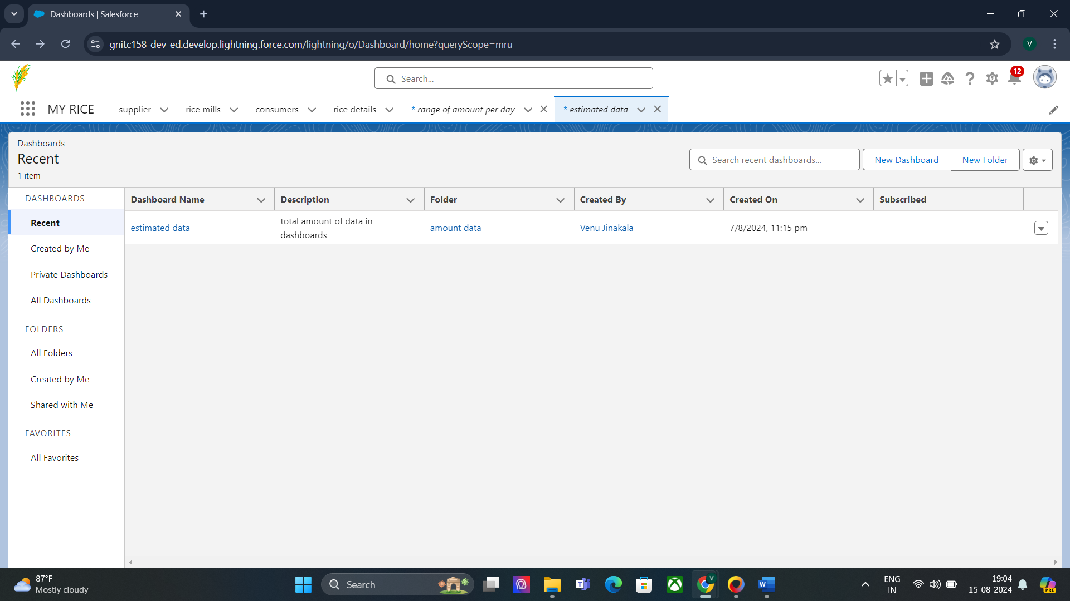

#### Task 33:

#### Create Dashboard

1. Go to the app >> click on the Dashboards tabs.

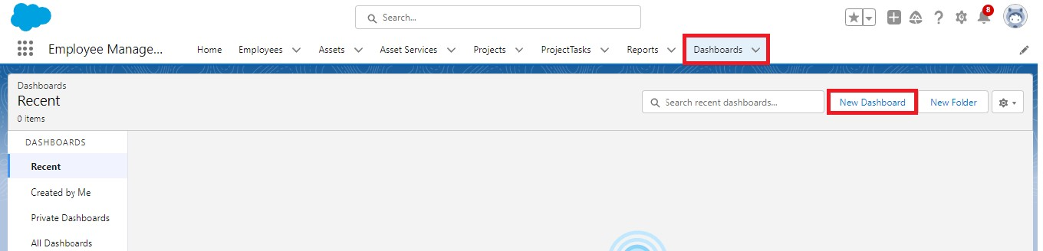

2. Give a Name and select the folder that was created, and click on create.

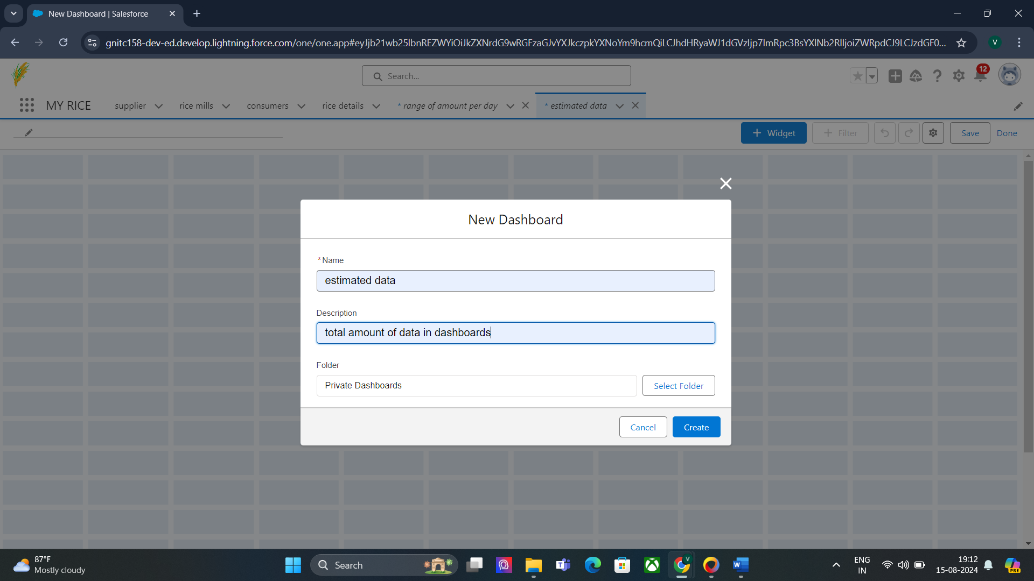

1. Select add component.



1. Select a Report and click on select.

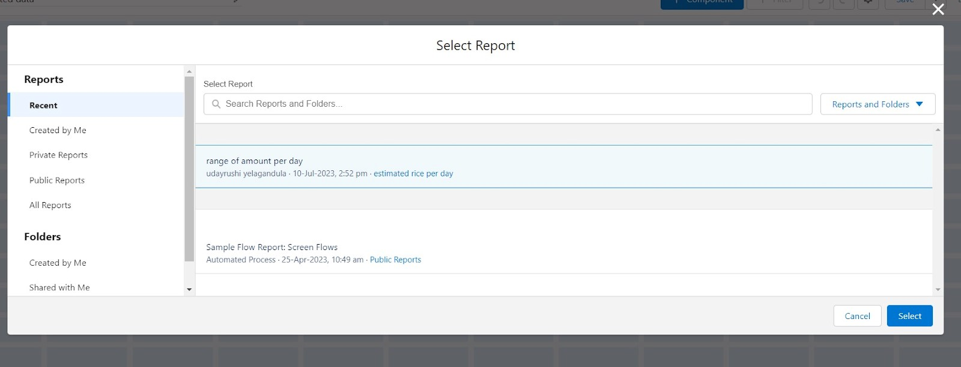

1. Preview is shown below.

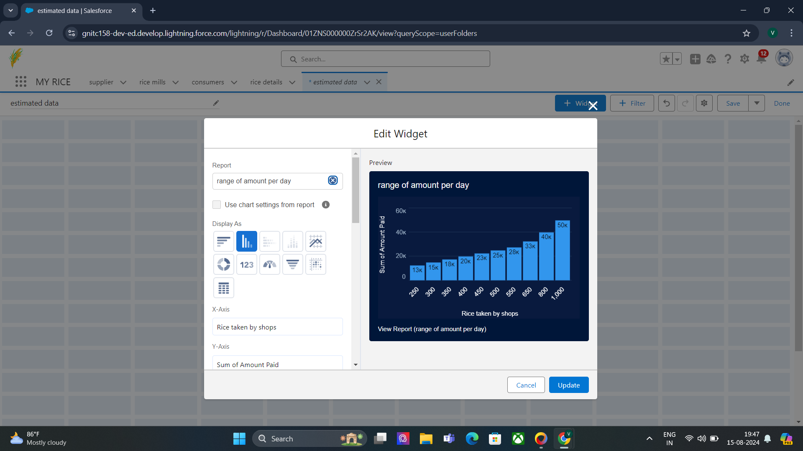

Display as>> vertical bar chart

X-axis >> rice taken by shops

Y-axis >> sum of amount

Y-axis range >> automatic

Sort by >> rice taken by shops

Component theme >> dark.

Add the component

Again select add component with above same steps

1.display as donut chart

2.sort by >> sum of amount

3.title>>range of amount per day

4.component theme dark

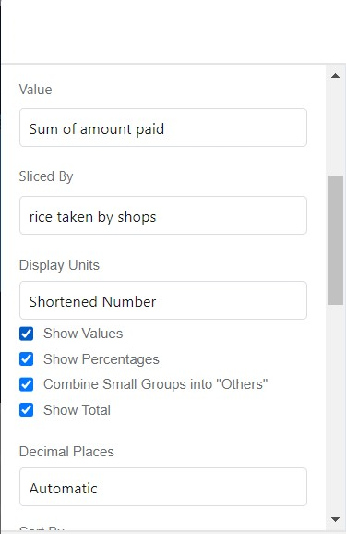

5.Click add.

6.Click save and done.

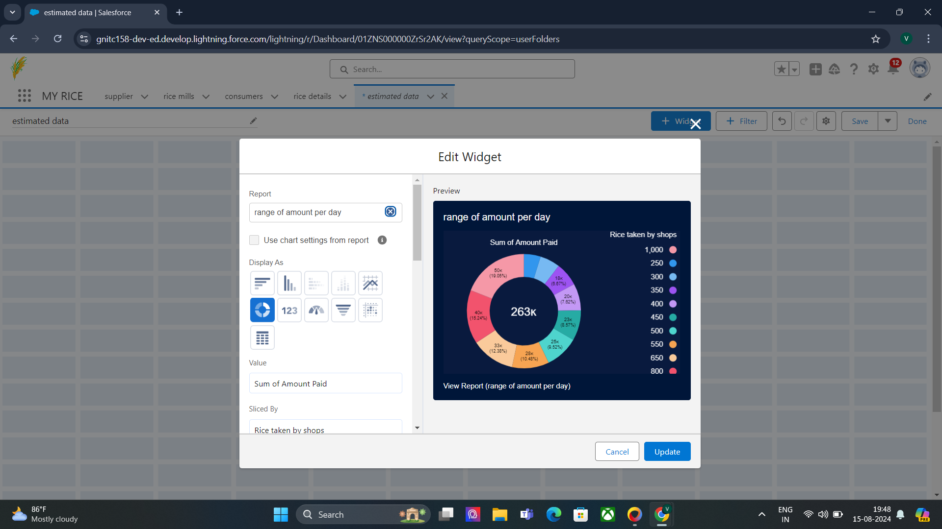

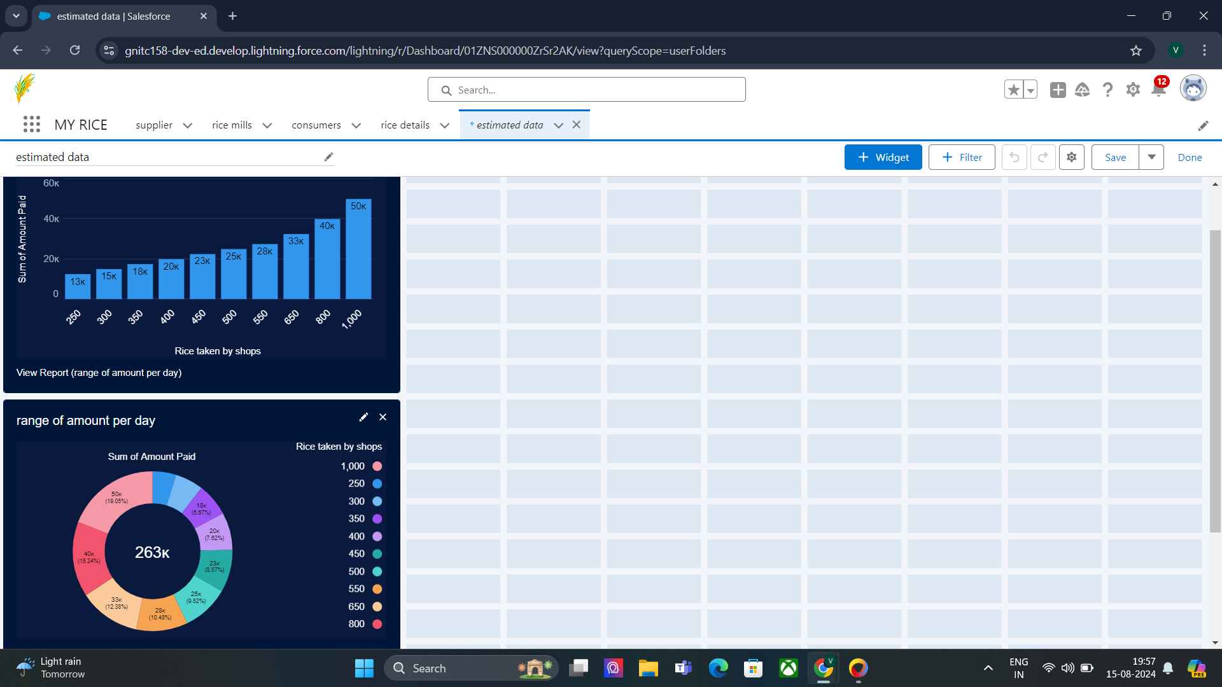

#### Task 34:

#### Creating an Apex Class(ConsumerRecord)

1. Login to the Salesforce account and navigate to the gear account in the top right corner.

2. Then we can see the Developer console. Click on the developer console and you will navigate to a new console window.

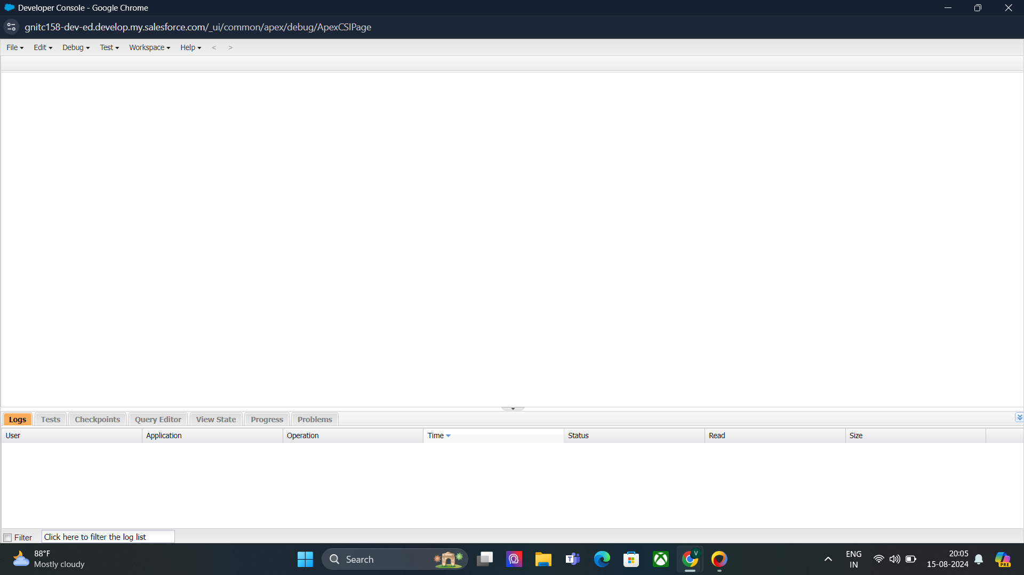

3. Then you can see many tools in the Toolbar of the new console window. Click on File, New and Apex Class.

4. Enter the name of the class(ConsumerRecord) to create a new class file.

#### Code Snippet :

class ConsumerRecord {

public static void sendEmailNotification (List<consumer__c> con){

for(consumer__c c:con)

{

Messaging.SingleEmailMessage email = new Messaging.SingleEmailMessage();

email.setToAddresses( new List<String>{c.email__c});

email.setSubject('Welcome to our company');

email.setPlainTextBody('Dear ' + ' '+ ',\n\nWelcome to MY RICE!'+'You have been seen as a valuable customer to us. PLease continue your journey with us, while we try to provide you with good quality resources.'+'\n'+

"We are proud to associate with valuable customers like you and we look forward to collaborating with you by providing more and more exciting discounts or even product offers too.' + '\n'

+'So why taking a step back, take a leap of faith and shop with us more, while we provide with the valuable products and offers'+'\n'+'\n'+'\n'+

'Thankyou for buying '+ '' +'Here are some of the products that are brought by the customers who similarly bought products like this'+'\n\n');

Messaging.sendEmail(new List<Messaging.SingleEmailMessage>{email});

}

}

}

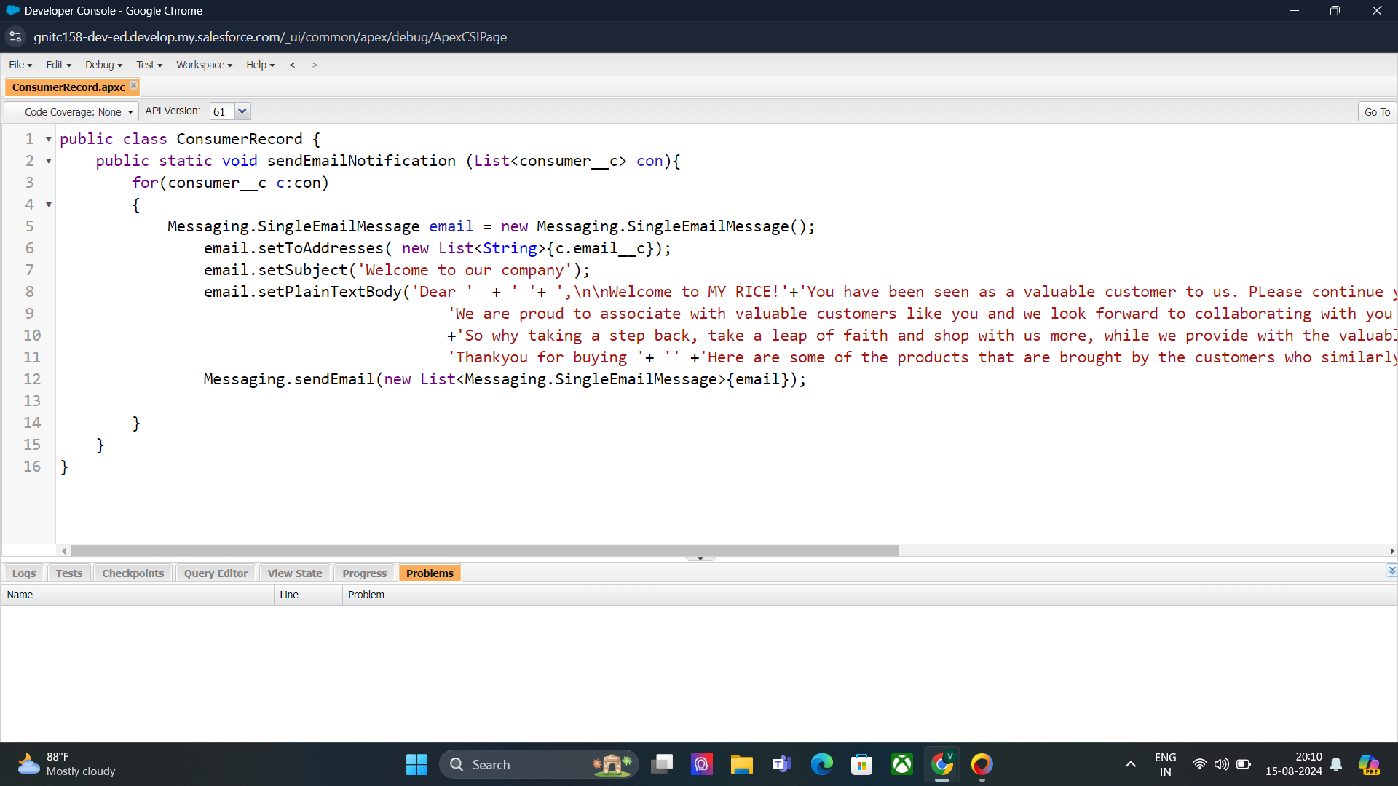

#### Task 35:

#### Creating an Apex Trigger

#### create a new trigger :

1. While still in the trailhead account, navigate to the gear icon in the top right corner.

2. Click on developer console and you will be navigated to a new console window.

3. Click on the File menu in the toolbar, and click on new >> Trigger.

4. Enter the trigger name as "consumerTrigger" and the object as "consumer__c" to be triggered.

#### Trigger code:

trigger consumerTrigger on consumer__c (After insert) {

if(trigger.isAfter && trigger.isInsert) {

ConsumerRecord.sendEmailNotification(trigger.new);

}

}

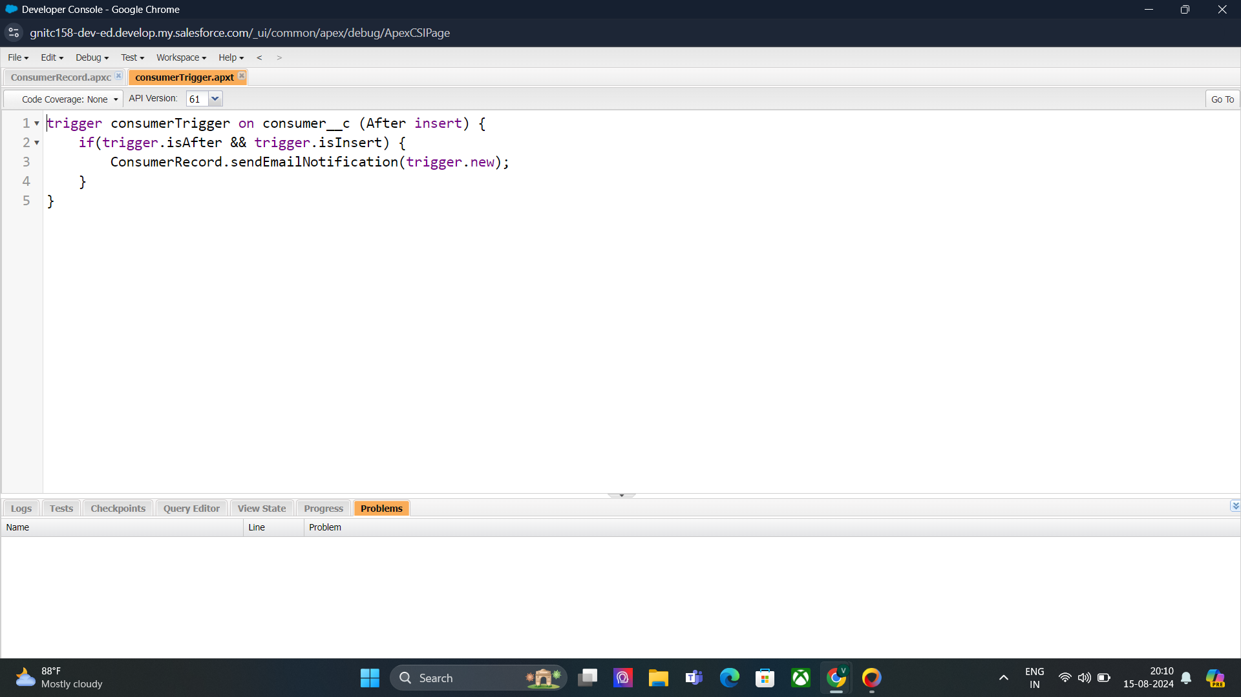

# Thank You